A close up of a sign

Description generated with very high confidence



**100 Riverside Parkway, Suite 201**

**Fredericksburg, Virginia 22406**

**571-991-5737**

**Early Warning System**

**Solution Design and Requirements**

**Prepared for**

**Commonwealth of the Northern Mariana Islands Public School System**

**1 August 2024**

This document was produced by

DBDRIVEN, LLC

CNMI PSS SLDS DBDriven Project Contacts:

**Project Manager:**

Will Goldschmidt, PMP

[Will@dbdriven.solutions](mailto:Will@dbdriven.solution) | 540.419.5922

**Administrative Point of Contact:**

Tamra Arant | Project Coordinator

[Tamra.Arant@dbdriven.solutions](mailto:Tamra.Arant@dbdriven.solutions)

**This Page Intentionally Left Blank**

Early Warning System (EWS) Solution Design and Requirements

CNMI PSS Early Warning System

## Document Status

|  |  |
| --- | --- |
| Title | Early Warning System (EWS) Solution Design and Requirements |
| Author(s) | Will Goldschmidt, Tamra Arant, Paulo Dorado |
| Team | CNMI PSS SLDS Project Team |
| Version | V3.0 |
| Status | Draft |

## Change Record

|  |  |  |  |
| --- | --- | --- | --- |
| Date | Author | Version | Change reference |
| 12 December 22 | T Arant | V1.0 | Draft for CNMI review/discussion |
| 16 January 23 | T Arant | V1.1 | Added section 4.3.3, Student Feedback Interventions |
| 7 February 23 | T Arant | V1.2 | Additional EWS Indicators added |
| 15 February 23 | T Arant | V1.2 | Final Draft (changes after this point will be V2) |
| 25 October 23 | T Arant | V2.0 | * Scope of EWS Project broadened to include MS, HS (1.2) * Objective 2 to include K-12th grade students (1.3) * Assumption 5 to increase total users in system (2.1) * User Access 3 to include K-12th grade teachers (3.1) * User Access 7 to increase total users in system (3.1) * Business Rules table for EWS updated/added Indicators (3.4.3.1) * Student Attribute table added (3.4.3.2) * Dataflow 2 added Credits Earned data element (4.2.1.2) * Data Element 16 added for Credits Earned (4.3.2) |
| 24 July 24 | T Arant | V3.0 | * Added section 10 and 11 for EWS enhancement requirements |

**Table of Contents**

Document Status iv

Change Record iv

1 Executive Summary 1

1.1 Project Background 1

1.2 Project Statement of Purpose 1

1.3 Key Objectives 1

1.4 Project Stakeholders 2

2 Project Overview 2

2.1 Project Assumptions 2

2.2 Key Constraints 2

2.3 Risks 3

2.4 Items Out of Scope 3

3 EWS Solution Overview 3

3.1 User Access and Security Requirements 3

3.2 Access Requirements 4

3.3 Export Requirements 4

3.4 EWS Business Rules 4

3.4.1 Anomaly Detection 4

3.4.2 Flags Using Indicators 5

3.4.3 Scoring and Weights 5

3.4.3.1 Indicator Business Rule Table 5

3.4.3.2 Student Attribute Table 7

4 Technical Planning and Design 7

4.1 Data Security Considerations 7

4.2 High Level Data and Process Flow Description 7

4.2.1 Data Interactions 7

4.2.1.1 Context Level Dataflow Diagram 8

4.2.1.2 Textual Context Level Dataflow 8

4.2.2 Data Refresh Requirements 8

4.2.3 High-Level Processing 8

4.2.3.1 High Level Data Ingestion 9

4.2.3.2 Data Factory Data Flow 9

4.3 Reporting 9

4.3.1 Measures 9

4.3.2 Data Elements 10

4.3.3 Student Feedback Interventions 10

4.3.3.1 Student Feedback Panel Options 11

5 EWS Layout and Design 11

5.1 Page Designs 11

5.1.1 District Page 12

5.1.2 School Page 12

5.1.3 Classroom Page 13

5.1.4 Student Page 13

5.1.5 Footnote and Definition Requirements 14

6 Change Requests to Original Specifications 14

7 Conclusions and Next Steps 15

8 Glossary of Terms 15

9 Appendix A. CNMI PSS EWS Requirements Matrix 16

10 Appendix B. CNMI PSS EWS Version 3 Requirements 16

10.1 EWS Reports 16

10.1.1 Staff Activity Report 16

10.1.2 Student Intervention Analysis Report 16

10.2 Dashboard and Visuals 16

10.2.1 Dashboard 16

10.2.2 Visuals 16

10.3 Flags, Indicators, Risk Levels, and Attributes 16

10.3.1 Flags and Indicators 16

10.3.2 Risk Levels 16

10.3.3 Attributes 16

10.4 Intervention Management 17

10.4.1 Intervention Categories and Options 17

10.4.2 Intervention Outcomes 17

10.5 Demo and Training Environment 17

11 Appendix C. CNMI PSS EWS Requirements Matrix 17

# Executive Summary

## Project Background

The CNMI PSS established a Reading Stakeholder Group, which includes REL Pacific. The goal of the team is to support the CNMI PSS's efforts to improve early literacy. The Early Warning System (EWS) is a starting point for identifying and supporting students who may be at risk of not proficiently reading by 3rd grade.

The stakeholder group developed indicators and processes which were piloted at elementary schools during SY 2020-2021. These indicators come from multiple sources (e.g., ChildPlus and AdminPlus student information systems, ACT Aspire) with data sorted on Microsoft® Excel files or Google Sheets by schools and shared through a secure portal.

The EWS system will ease the burden on schools which have been reliant on manually populating EWS data, from multiple sources, to include spreadsheets. The EWS solution will analyze and identify at risk students using data from student information and assessments and present this information to decision makers from the district to the classroom through web-based visualizations and reports.

## Project Statement of Purpose

The EWS is to provide educators with measurable data over time for individual students and student groups. The objective of the EWS is to provide accurate identification of students in need of support, assist in determining the kinds of support they need, and provide data to evaluate over time the effectiveness of programs implemented.

The EWS enhances academic achievement and mitigates dropout issues for at-risk students. The solution provides educators with easily accessible data on validated indicators that are predictive of their K-12th grade students’ academic success as well as success in reading by 3rd grade for elementary students. The EWS enables educators to record, track, and analyze the impact of mitigating actions — interventions and outcomes — in response to information from the indicators.

The EWS helps to identify individuals and groups of students who need particular support as well as provides information for broader school and district policy decisions that will result in greater support.

## Key Objectives

This section includes the overarching project and business objectives regarding the EWS Solution. Key objectives are defined as the requirements needed to meet the purpose of the EWS Solution.

|  |  |
| --- | --- |
| **ID** | **Objective** |
| OB1 | Mitigate academic achievement and dropout issues for at-risk students |
| OB2 | Provide educators with easily accessible data on validated indicators that are predictive of their K-12th grade students’ academic success and success in reading by 3rd grade for elem. students |
| OB3 | Provide educators timely, actionable insight into the students who may need additional support |
| OB4 | Identify individuals and groups of students who need particular support, and help provide information for broader school and district policy decisions that will result in greater support overall |
| OB5 | Enable educators to record, track, and analyze the impact of the actions — interventions and responses — in response to information from the indicators |
| OB6 | Provide aggregated data at the individual, classroom, grade, school, and district level (and state level for statewide systems), and disaggregated by different student sub-groups, including customized sub-groups identified by schools and districts |

## Project Stakeholders

| **Name** | **Title** |
| --- | --- |
| Annette Pladevega Sablan | Project Director |
| Jeannifer Cubangbang | SLDS Technical Manager |

# Project Overview

## Project Assumptions

This section includes the project team’s assumptions regarding the EWS Solution. Project assumptions are defined as an accepted precondition or set of preconditions that may impact the design, development, and implementation of the EWS Solution.

|  |  |
| --- | --- |
| **ID** | **Assumption** |
| AS1 | All EWS Users will also be included in Infinite Campus staff |
| AS2 | All EWS components will be hosted in the Cloud (MS Azure) |
| AS3 | All data cleansing activities by CNMI PSS must be completed in IC by 1 March 2023 |
| AS4 | Student and Assessment data included in the EWS Solution may include School Years 2021 and forward |
| AS5 | The EWS will have approximately 500+ Users |
| AS6 | All EWS Solution data will be managed in accordance with the Family Educational Rights and Privacy Act (FERPA) (20 U.S.C. § 1232g; 34 CFR Part 99) Regulations regardless of waiver status |
| AS7 | CNMI will provide Assessment vendors a student roster to include the IC student ID |
| AS8 | All Assessment data will include the IC student ID |
| AS9 | There will not be any data suppression within the EWS |

## Key Constraints

This section identifies the key constraints for the EWS Solution as identified by DBDriven. Key constraints are defined as known or unknown factors that may impact the design and implementation of the EWS Solution. Additionally, key constraints may influence the development or usability of certain functionalities in the final solution.

|  |  |
| --- | --- |
| **ID** | **Key Constraint** |
| CO1 | EWS Solution must meet or exceed the FERPA (20 U.S.C. § 1232g; 34 CFR Part 99) |
| CO2 | Security is dependent on properly managed and entered roles/permissions by CNMI in SIS/IC |
| CO3 | EWS Solution must ensure web accessibility compliant with the Americans with Disabilities Act (ADA) |

## Risks

The DBDriven Project Team has identified the following risks associated with the EWS Solution.

|  |  |  |
| --- | --- | --- |
| **ID** | **Risk Description** | **Mitigation Strategy** |
| RI1 | Late files or incomplete data will result in incomplete and/or an inaccurate EWS | * DBDriven will work with CNMI to identify and mitigate missing and/or erroneous data. * DB Driven will continue to process data into the EWS Solution throughout the current FFP (Firm Fixed Price) contract period. |

## Items Out of Scope

|  |  |
| --- | --- |
| **ID** | **Items Out of Scope** |
| OOS1 | Documentation/Forms on EWS Program Management and Business Processes |
| OOS2 | Data Cleansing |

# EWS Solution Overview

## User Access and Security Requirements

This section identifies the user access and security requirements necessary for the EWS Solution and the CNMI PSS staff who have access to specific components of the EWS Solution. User Access and Security Requirements are defined as requirements that contribute to roles and permissions needed to view the dashboard and data as well as any additional security or authentication requirements necessary.

|  |  |  |
| --- | --- | --- |
| **ID** | **User Access and Security Requirement Description** | **User / Comments** |
| UR1 | A user is required to be registered as staff in IC, along with their role | Roles:   * Principal   • Asst Principal  • Counselor  • Title 1 Teacher  • SpEd Teacher  • ELL Teacher |
| UR2 | Users cannot see data outside of their group/role assignment |  |
| UR3 | **Public School Teachers** will only have access to the EWS component for students in their class(es) at the specific school they teach | K-12th Grade CNMI PSS Teachers |
| UR4 | **School Administrative Staff** will only have access to the EWS component for all students and classrooms at the specific schools they work |  |
| UR6 | **District Administrative Staff** will have access to all EWS components across all schools and students in the district |  |
| UR7 | ~500+ Users |  |
| UR8 | User password management will comply with the CNMI Stakeholder Security Standard | Current standard requires three of four attributes (upper case, lower case, numbers, special characters) be used in the password |
| UR9 | Password resets will be managed through email notices and self-service | Email address provided through Infinite Campus |

## Access Requirements

This section identifies the access requirements for the EWS Solution. Access requirements are defined as any requirements pertaining to the access of the solution to users.

|  |  |  |
| --- | --- | --- |
| **ID** | **Access Requirement Description** | **Additional Comments** |
| D1 | The EWS Solution will be accessible to CNMI PSS staff through a webpage URL |  |
| D2 | The EWS Solution will enforce user access (district and school admin staff, teachers) and permissions as defined within IC |  |

## Export Requirements

This section identifies all export requirements for the EWS Solution. Export requirements are defined as any requirements related to exporting information available on the solution user interface. The EWS Solution will support the export of students at risk by school. The list will be filtered based on the current user’s permissions.

## EWS Business Rules

This section details business rules for the EWS Solution to include flags and indicators, scoring, scoring weights, thresholds, and references. The purpose is to provide educators with measurable data over time for individual students and student groups. The EWS focuses on indicators that are both highly predictive of individuals and groups of students who need particular support and subject to modification through the actions of educators and other concerned adults. The EWS will provide quarterly information (history) for STAR Early Literacy, STAR Reading, and daily updates for ELA Grade, Retention, Attendance and Discipline records to capture the key indicators of attendance, behavior, and course performance (e.g. ABC indicators).

Indicators are quantifiable measures of behaviors, skills, and characteristics that are highly predictive of students’ being on track for reading success by the third grade. Indicators are limited to the most valuable (a few good indicators are more actionable than many). Thresholds that indicate the type of action needed — indicating whether to take action now, not yet, or not at all — may vary by context, but will fall within a numerical range established by evidence.

### Anomaly Detection

The EWS will provide the ability to detect, flag and score the target population based on weights and thresholds. Collectively, the EWS provides an anomaly detection algorithm, which may be modified to refine the detection. The EWS will collect intervention and outcome information as defined by CNMI for feedback into improving calibration of the anomaly detection.

### Flags Using Indicators

CNMI stakeholders have provided a set of business rules (defined as indicators) to determine the criteria for setting a flag on a target population which is screened through the EWS. The target population will be screened for every indicator provided and results stored in the EWS Solution. Each indicator is further defined by its unit of measure. For example, if the attendance indicator is 3 or more absences within the last 90 days, then the unit of measure is “number/frequency of absences within 90 days”.

The “Early Warning” indicator for a student is indicated by an “urgent” score within Star Renaissance Early Literature and/or Star Renaissance Reading. The “At Risk” indicator is a single instance of any indicator listed in *Table 3.4.3.1* (attendance, school transfer, behavior, etc.). The EWS will add or remove indicators for attendance, school mobility, and behavior using a 90-day rolling period.

### Scoring and Weights

Within the EWS, once the target population is properly flagged, a score or weight may be applied to determine the severity of the intervention. The value applied may be based on frequency, or on a combination of indicators, which in turn bolster or multiply the score or weight for the target population. The EWS supports three ways to aggregate the scores of the indicators:

* **Counting Total Indicators Tripped –** How many times did the student trip the indicators defined
* **Thresholds –** When a defined threshold is met such as a scoring frequency for how many times an indicator is tripped, an increase or multiplication of weight is performed. Similarly, a category may be created from a set of the target population, if a threshold is met by all of them. For example:
  + If a student trips a threshold of three absences in a quarter, the higher risk indicated by this threshold is subsequently weighted higher by multiplying the attendance indicator score by 3
  + If a student reaches 100 points in total, the weight is considered “High Priority” --anything less than 25 is considered “Low Priority”
* **Combination of Indicators** - When a combination of predetermined indicators is tripped, a student is immediately flagged as part of a category. For example, if a student is absent more than five times and moved to 3 different schools in a school year, the score is weighted high to signal the student requires “Urgent Intervention”.

A final tally of score or weight is calculated for each student in the target population depending on the defined business rules.

#### Indicator Business Rule Table

|  |  |  |  |
| --- | --- | --- | --- |
| **ID** | **Indicator** | **Business Rule Description** | **Note** |
| BR1 | Attendance - 90 Day Rolling | Students who have 3 or more absences within 90 days. Every Unexcused Absence is counted.  number/frequency of absences per 90 day period | Elem, MS, HS |

|  |  |  |  |
| --- | --- | --- | --- |
| **ID** | **Indicator** | **Business Rule Description** | **Note** |
| BR2 | Attendance - Semester | Students who have 10 or more unexcused absences per semester (without block schedule) | Elem, MS, HS |
| BR3 | Attendance - Block Schedule | Students who have 5 or more unexcused absences per semester (for block schedule) | Cha Cha MS only |
| BR4 | Attendance - Chronic Absenteeism | Students who have 18 or more (10% of 180 school days missed) unexcused absences | Elem, MS, HS |
| BR5 | Behavior | Students who have 1 or more behavior incidents within 90 days | >1 office referrals |
| BR6 | STAR Early Literacy | Students who place at Urgent Intervention in STAR Early Literacy | ‘RenaissanceBenchmarkCategoryName’ |
| BR7 | STAR Reading | Students who place at Urgent Intervention in STAR Reading | ‘RenaissanceBenchmarkCategoryName’ |
| BR8 | STAR Math | Students who place at Urgent Intervention in STAR Math | ‘RenaissanceBenchmarkCategoryName’ |
| BR9 | ELA | Students who score a 1 or 2 |  |
| BR10 | Math Grade | Students who score a 1 or 2 |  |
| BR11 | School Mobility | Students who have attended 2 or more elementary schools between kindergarten and 5th grade. School Mobility is evaluated by any school move in the previous or current school year. Ignore summer sessions. |  |
| BR12 | Retention | An indicator (flag) on whether the student has been retained |  |
| BR13 | Low Grades | Students who have a score <63% for any course at the end of the 1st Quarter or the cumulative average after each quarter. | MS, HS only |
| BR14 | Credit Shortage | <4 credits earned by the end of 1st semester of 9th grade.  <7 credits earned by the end of 2nd semester of 9th grade.  <10 credits earned by the end of 1st semester of 10th grade.  <14 credits earned by the end of 2nd semester of 10th grade.  <17 credits earned by the end of 1st semester of 11th grade.  <21 credits earned by the end of 2nd semester of 11th grade.  <24 credits earned by the end of 1st semester of 12th grade.  <28 credits earned by the end of 2nd semester of 12th grade. | HS only |

#### Student Attribute Table

In addition to the indicator business rules to flag students at risk, student attributes are defined as follows to identify groups of students.

|  |  |  |
| --- | --- | --- |
| **ID** | **Attribute** | **Business Rule Description** |
| AT1 | Preschool experience | Student attribute if attended early head start or head start. This data is sourced from ChildPlus. |
| AT2 | Special Education | Student attribute if in Individualized Education Program (IEP) |
| AT3 | English Learner | Student attribute if enrolled/designated an English Learner (ELL) |
| AT4 | Title 1 | Student attribute if designated as Title I |

# Technical Planning and Design

## Data Security Considerations

Protecting the identities of students and staff is vitally important. The data storage and report generation and delivery will take place within a secure cloud-based environment.

The EWS solution will meet or exceed the Family Educational Rights and Privacy Act (FERPA) (20 U.S.C. § 1232g; 34 CFR Part 99). This includes logging access and partitioning the data to only allow persons with "a reasonable need to access student's personal information" (*FERPA regulation*) to see any given student artifacts.

The EWS will apply FERPA protections to both the student data and aggregations of data for a specific student.

## High Level Data and Process Flow Description

### Data Interactions

The primary data provider for the EWS solution is the K12 SLDS. Student information updates will be provided nightly to the EWS from the SLDS.

The EWS will generate and store data necessary for operation of the solution, such as intervention data and trigger data in the EWS Operational Database. All EWS components, to include data, will be retained within Azure.

#### Context Level Dataflow Diagram

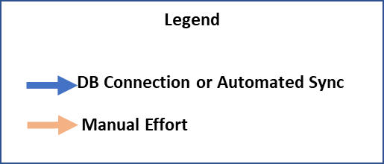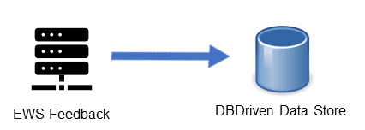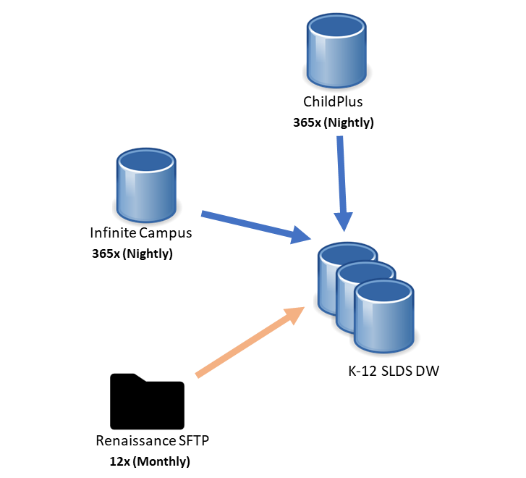

#### Textual Context Level Dataflow

| **ID** | **Agent** | **Data Coming From Data Source** |
| --- | --- | --- |
| DF1 | ChildPlus | Preschool Experiences |
| DF2 | Infinite Campus | Name Grade Level Discipline ELA Grade Credits Earned  Attendance SpEd Mobility ELL Retention |
| DF3 | Renaissance | STAR Early Literacy STAR Reading STAR Math |
| DF4 | EWS | Feedback entered by CNMI PSS staff on student intervention actions |

### Data Refresh Requirements

This section identifies all requirements surrounding the refreshing of data. Data refresh requirements include descriptions of data to be refreshed and the frequency of data refresh.

| **ID** | **Dataflow Name** | **Dataflow Description** | **Refresh Rate** |
| --- | --- | --- | --- |
| DD1 | ChildPlus | Refresh of pre-school/kindergarten data | Nightly |
| DD2 | Infinite Campus | Refresh of K-12 data | Nightly |
| DD3 | Renaissance | Refresh of STAR Assessment data | Monthly |

### High-Level Processing

The required data sources for EWS will populate in the EWS Staging Environment as detailed in section 4.2.1. This section diagrams and explains how data flows from the staging environment.

The data is stored in the EWS Staging Environment to transform the data and create datasets where applicable for an efficient EWS reporting. A web app will be built for users to interact with the dashboards and submit information for feedback (intervention, actions taken, indicator effectiveness, scoring administration, etc.).

Data events will trigger the EWS ETL to process or refresh the data (total or selective processing) for an updated view of the EWS in near real-time in conjunction of the Ed-Fi refresh schedule. When data events are detected, data services will initiate a series of processes to update the datasets, which in turn will refresh the EWS front-end. The data events will be determined by the CNMI stakeholders. Diagram 4.2.3.2 shows the process for when the data events are fired.

|  |  |
| --- | --- |
| **ID** | **High Level Processes** |
| HLP1 | Data sources (ChildPlus, Renaissance, Infinite Campus) loaded in staging environment |
| HLP2 | Data from staging transformed to the interim tables |
| HLP3 | Indicators identified on the target student population |
| HLP4 | Students with indicators scored and prioritized based on weights defined by CNMI Stakeholders |
| HLP5 | Initial reports created based on target population and business rules |
| HLP6 | Reports accessible through a web portal |
| HLP7 | CNMI users login to web portal for report viewing and feedback collection |

#### High Level Data Ingestion

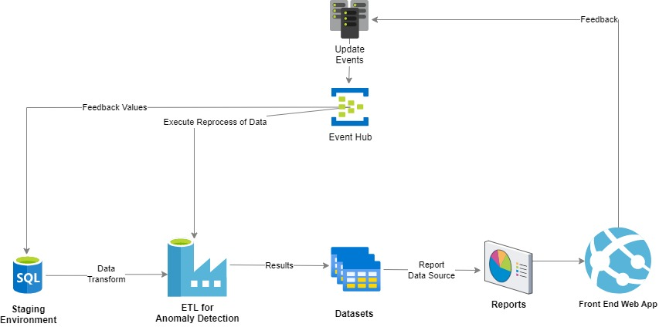

#### Data Factory Data Flow

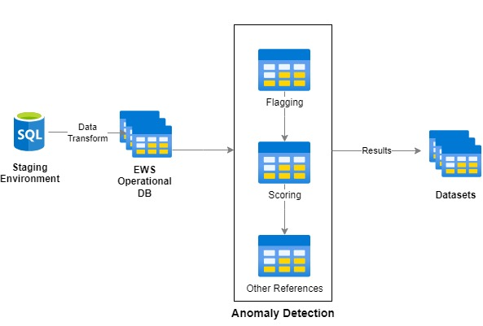

## Reporting

DBDriven will create datasets in conjunction with an ETL data flow to support the measures and data elements displayed for reporting.

### Measures

The measures identified so far include the distinct count of student unique identification numbers and the sum score of the ABC indicators. The measures may be extended to include thresholds.

### Data Elements

Data elements are utilized to slice and filter the data to create the reports. Based on the current file layout, the measures will be sliced and filtered on the fields listed in the data elements table. Datasets for reporting will be created based on these data elements when producing the reports.

|  |  |  |
| --- | --- | --- |
| **ID** | **Data Elements** | **Data Source** |
| D1 | UID | IC |
| D2 | Name | IC |
| D3 | ELA Grade | IC |
| D4 | Count of schools attended (school mobility) | IC |
| D5 | Grade Level | IC |
| D6 | Unexcused Absence | IC |
| D7 | Tardy | IC |
| D8 | Discipline Incident | IC |
| D9 | isSpEdProgram | IC |
| D10 | isELL | IC |
| D11 | Retention (repeated grade) | IC |
| D12 | STAR Reading District Benchmark | Renaissance |
| D13 | STAR Early Literacy District Benchmark | Renaissance |
| D14 | attendedPreK | ChildPlus |
| D15 | School | IC |
| D16 | Credits Earned | IC |

### Student Feedback Interventions

The EWS Solution will provide CNMI PSS staff a list of predetermined interventions on the Student Page (see section *Student Page,* *5.1.4*). When an intervention is selected, the solution will display fields to record the start and end dates. Multiple interventions may be checked for an individual student. Other functions may include the options listed in *Table 4.3.3.1*.

|  |  |
| --- | --- |
| **ID** | **Intervention** |
| IV1 | Parent contact (email, phone, etc.) |
| IV2 | Student and/or parent meeting with School Team |
| IV3 | Student goal-setting meeting |
| IV4 | Review cumulative folder |
| IV5 | Daily homeroom check-in |
| IV6 | Enroll student in a positive activity |
| IV7 | Student self-advocacy email to teachers |
| IV8 | Binder or Homework organization session |
| IV9 | Buddy student |
| IV10 | Counseling |
| IV11 | Weekly academic check-in |
| IV12 | Before/after school meetings |
| IV13 | Lunch group |
| IV14 | Advocate check-in with teachers |
| IV15 | Positive phone call |
| IV16 | Working lunch (make-up work) |
| IV17 | Academic CICO plan (check-in/check-out) |
| IV18 | Office folder review |
| IV19 | Request Child Study Team |
| IV20 | Title I support |
| IV21 | SPED Teacher/aide support |
| IV22 | ELL Teacher support |
| IV23 | High-Dosage Tutoring |
| IV24 | AmeriCorps Tutoring |
| IV25 | Positive Behavior Intervention |
| IV26 | Small reading group |
| IV27 | *Other; Please list: (Free Text Box) |

#### Student Feedback Panel Options

|  |  |  |
| --- | --- | --- |
| **ID** | **Feedback Option** | **Comment** |
| FB1 | Intervention Status | New, Active, Closed |
| FB2 | Status Change Reason | Remediated, Transferred Out |
| FB3 | Responsible Role (primary) | Classroom Teacher,  ELL Teacher,  Counselor,  SpEd Teacher,  Title 1 Teacher |
| FB4 | Intervention Log | History of interventions with start/end dates |
| FB5 | Notes | Free text field (cannot report on free text field) |

# EWS Layout and Design

The EWS will be developed as an interactive web application. The solution will provide four different pages with visuals appropriately designed for each. The four pages are District, School, Classroom and Student. The solution will be web accessibility compliant with the Americans with Disabilities Act (ADA) regarding the theme for colors, fonts, and backgrounds chosen by the CNMI PSS Stakeholders. This section details the design at the conclusion of version V.1 (initial design).

## Page Designs

The EWS Solution will provide users access appropriate to the user’s role and permissions. Upon authentication, staff accessing the report will be limited to viewing pages and data corresponding to their group access (see section 3.1) and Figure 5.1. The landing page for each user is determined based on roles and permissions. For example, District users will land on the District page and have access to the School, Classroom and Student pages. School officials will land on the School page and will have access to the Classroom and Student pages but will not have access to the District page. Teachers will land on the Classroom page and have access to the Student page but not the School or District pages. Title 1, ELL, and SpEd teachers will be able to view students flagged for the respective program(s). Each page of the EWS provides CNMI PSS staff with analytics appropriate to the page as well as an ability to filter and analyze data.

|  |  |  |  |  |
| --- | --- | --- | --- | --- |
| **Users** | **EWS Pages** | | | |
|  | **District** | **School** | **Classroom** | **Student** |
| District Administrators | X | X | X | X |
| School Administrators |  | X | X | X |
| Teachers |  |  | X | X |
| Counselors |  | X | X | X |
| Title 1 Teacher |  |  |  | X |
| SpEd Teacher |  |  |  | X |
| ELL Teacher |  |  |  | X |

Figure 5.1

### District Page

The District EWS Page will provide a high-level perspective of EWS indicators organized for viewing and analysis by District personnel. The page will include analytics to compare and contrast CNMI PSS Schools. The District Page will provide the ability to filter or slice data based on demographics and other important data points identified during the project. District personnel will land on the District page of the EWS Solution. Figure 5.1.1 represents a notional District page.

Figure 5.1.1

### School Page

The School EWS Page will provide a high level perspective of EWS indicators organized for viewing and analysis by School personnel. The School Page will provide EWS information regarding a single School. School personnel will land on the School page of the EWS. Figure 5.1.2 represents a notional District page. Figure 5.1.2 represents a notional School page.

Figure 5.1.2

### Classroom Page

The Classroom EWS Page will provide EWS indicators organized for viewing and analysis by a teacher. The Classroom Page will provide an analysis of class of students. Teachers will land on the Classroom page of the EWS. Figure 5.1.3 represents a notional Classroom page.

Figure 5.1.3

### Student Page

The Student Page provides detailed information for a specific student. In addition to displaying the status of each EWS indicator, the Student page will allow authorized personnel to capture feedback on intervention actions as well as outcomes, as defined by CNMI PSS in section *4.3.3, Student Feedback Interventions*. Figure 5.1.4 represents a notional District page.

Figure 5.1.4

### Footnote and Definition Requirements

This section contains the footnotes identified as part of the EWS Solution and details the requirements for sequencing and placement on the page.

|  |  |  |  |
| --- | --- | --- | --- |
| **ID** | **Word or Acronym** | **Definition or Explanation** | **Additional Comments** |
| FN1 |  |  |  |

# Change Requests to Original Specifications

Change requests will be documented in Azure DevOps (ADO). The relative works items will be reviewed and approved in a separate document similar to the following form, and then appended to this Design and Solution Requirements document in a new version.

**Requested Change:**

|  |  |
| --- | --- |
| Change Request ID: |  |
| Change request date: |  |
| Requester Name: |  |
| Requester Department: |  |
| Description of the change: | |
|  | |
|  | |
|  | |
| Reason for the request: | |
|  | |
|  | |

**Impact of change on the project:**

|  |  |
| --- | --- |
| Estimated number of hours: |  |
| Change to implementation date: |  |
| Resources required: |  |
| Risk/Quality impact: |  |

**Approval of change:**

Project Sponsor: ___________________________________

Date of approval: ______________________________

# Conclusions and Next Steps

The CNMI PSS EWS Solution Design and Requirements document and the CNMI PSS Report Requirements Matrix represent the system requirements gathered as of the conclusion of the Discovery phase. Additional requirements will be identified by CNMI PSS stakeholders and included within this documentation.

# Glossary of Terms

|  |  |  |
| --- | --- | --- |
| **Term/Acronym** | **Definition / Description** | **Additional Comments** |
| Assumption | An accepted precondition or set of preconditions that will influence the creation of the report. |  |
| Business Question | The primary objective and purpose for the report, as defined by the stakeholders at the outset of the project. |  |
| Business Rules | A rule that defines or constrains some aspect of the functionality of the report and acts as a mechanism to assert structure and control over workflow. |  |
| Constraint | A known or unknown factor that may impact the design, implementation, or usability of some or all functionalities of the report. |  |
| Distribution Requirements | A requirement related to the access of internal CNMI PSS EWS Solution components. |  |
| Export Requirements | A requirement related to the workflow for exporting tables from the report. |  |
| Key Parameters | A condition that contributes to the potential scope of the requirements. |  |
| Report User | An individual or class of users for the report defined by specific sets of roles and permissions. |  |
| Risks | A circumstance or set of circumstances that exposes the project to danger in terms of scope, functionality, and/or budget. |  |
| Azure DevOps | Current name for the source control tool to manage version control, issue tracking, and application lifecycle management |  |
| User Access and Security | A requirement contributing to roles and permissions needed to view the report, as well as any additional security or authentication necessary for the creation of this report. |  |

# Appendix A. CNMI PSS EWS Requirements Matrix

Sent as a separate Excel document, **CNMI PSS Report Requirements Matrix**.

# Appendix B. CNMI PSS EWS Version 3 Requirements

This section describes the EWS application enhancement requirements to uphold and improve the objectives set forth in section 1.3 herein.

## EWS Reports

Provide report capabilities internal to the EWS for staff usage and login activity tracking as well as for the analysis of student interventions.

### Staff Activity Report

Provide report capability internal to the EWS for staff usage and login activity tracking.

1. District Level
   1. Count of staff logins by each school by month
      1. Rolling time period?
2. School Level
   1. Count of staff logins at the school
      1. Rolling time period?
   2. Count of staff logins by user
      1. User name?
      2. Login date?
      3. Etc.?
      4. Rolling time period?

### Student Intervention Analysis Report

Provide report capability internal to the EWS for the analysis of student interventions.

1. District Level
   1. Intervention status (new, active, closed)
      1. Rolling time period?
2. School Level
   1. Intervention status (new, active, closed)
      1. Rolling time period?
   2. Count of intervention types at the school
      1. Current school year
   3. Intervention outcomes
      1. Remediated: Issue was resolved by taking corrective actions to address the underlying problem
      2. Transferred: Issue was handed over to another interventionist that is better suited to handle it
      3. Dismissed: Issue was reviewed and determined to be unfounded or not requiring any further action
      4. Resolved: Issue was successfully addressed and closed after implementing a solution
      5. Completed: Planned intervention or task was completed as intended with all objectives met
3. Teacher Level
   1. Count of active interventions per student
      1. Current school year
   2. Intervention outcomes
      1. Remediated: Issue was resolved by taking corrective actions to address the underlying problem
      2. Transferred: Issue was handed over to another interventionist that is better suited to handle it
      3. Dismissed: Issue was reviewed and determined to be unfounded or not requiring any further action
      4. Resolved: Issue was successfully addressed and closed after implementing a solution
      5. Completed: Planned intervention or task was completed as intended with all objectives met
   3. Remediated = The issue was resolved by taking corrective actions to address the underlying problem
   4. Transferred Out = The issue was handed over to another interventionist that is better suited to handle it
   5. Completed = The planned intervention or task was completed as intended, with all objectives met
   6. Closed with recommendations = The issue was closed with specific recommendations for future actions or improvements.

## Dashboard and Visuals

Provide an enhanced dashboard with varying levels of detail to navigate to such as overview, reports, and trends.

### Dashboard

#### Sign-on Page

1. Incorporate new CNMI Logo
   1. Need logo
2. Add Welcome Message:
   1. Welcome to the CNMI PSS Early Warning System, a resource designed to help educators make data-informed decisions to intervene and improve outcomes for all students.
   2. Example Sign-on Page:
      1. 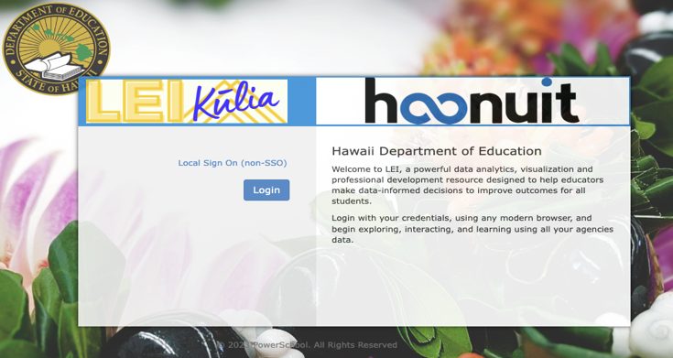

#### Landing Pages

1. Add the following links to current dashboards for District, School, and Teacher
   1. Technical documents and resources (which ones?)
      1. User Guide
      2. Training Materials (Google Link)
   2. Intervention list
      1. CNMI Intervention website URL
   3. Example:
      1. A screenshot of a toolkit

         Description automatically generated

#### District Landing Page

1. Change “Students By School Year” graph to Students by Grade (not by school year)
2. MSAA English and Math Performance Level (Mr T provided April)
3. WIDA Scale Score Overall and Scale Score Listening (Jan, Feb, March)

#### Student Detail Page

Add an additional tab to the student dashboard for Intervention Management

1. Example of student detail page with tabs
   1. 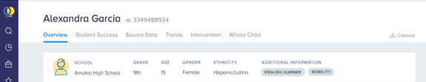
2. See Intervention Management section 10.4 for details

#### Student Roster

The Student Roster shall be updated with the following columns:

1. Condensed name, sortable
   1. Last
   2. First and Middle (merged)
2. Grade
3. Indicator icon/badge
   1. Single column with all indicators displayed in the same field for each student
   2. The name of the indicator will display on hover over of the badge
   3. Sortable by total indicators
4. Count of Open interventions, sortable by total
   1. Open = Active or New
5. Risk Level (i.e., Low, Medium, High)

### Visuals

#### Dashboard Visuals

The Dashboard shall be updated with the following visuals:

1. District View
   1. Make Counts visible without hovering over graphs
      1. Students By School Year
      2. Student By Grade Level
      3. Student By Risk Indicator
2. School View
3. Student Roster
   1. Add column for Count of Open Interventions per Student
      1. New
      2. Active
         1. Open = New and Active status’ once the Intervention has a Start Date
         2. NOTE – Require Start and End Date so that Intervention Status is intuitively changed from New to Active and Active to Closed within the dates entered. Have an option to change the End Date so Closed can return back to Active

Add Visuals to the following:

1. Student Page
   1. Longitudinal Indicator information with side-by-side year comparison
      1. Course Grade
         1. Current and Previous Year
            1. Elementary by quarter - Q1, Q2, Q3, Q4
            2. Secondary by semester – S1, S2
         2. English
         3. Math
      2. STAR
         1. Current and Previous Year – S1, S2, Outcome/S3
         2. Math
         3. Reading
         4. Early Literacy
         5. NOTE – Some students will have MSAA instead of STAR
      3. Credit Shortage
         1. Show all credits earned (it is not showing credits not earned)
         2. NOTE – Need to discuss business rule for the summer
      4. Behavior
         1. Add column for the Category of Offense
            1. C1, C2, C3, C4, and/or minor, serious, extreme
         2. NOTE – Not all incidents are listed (in progress, completed make a difference?)
            1. Example – Bowie, KHS
         3. NOTE – The filter feature on Credit Shortage needs to be talked about
2. Student Roster
3. Dashboard Update

## Flags, Indicators, Risk Levels, and Attributes

### Flags and Indicators

### Risk Levels

### Attributes

## Intervention Management

### Intervention Categories and Options

### Intervention Outcomes

## Demo and Training Environment

# Appendix C. CNMI PSS EWS Requirements Matrix

Sent as a separate Excel document, **CNMI PSS Early Warning System V.3 Requirements Matrix**.