A close up of a sign

Description generated with very high confidence



**100 Riverside Parkway, Suite 201**

**Fredericksburg, Virginia 22406**

**571-991-5737**

**Early Warning System (EWS) Phase II**

**User Manual**

**Prepared for**

**Commonwealth of the Northern Mariana Islands Public School System**

**November 28, 2023**

This document was produced by DBDriven.Net LLC.

A close up of a sign

Description generated with very high confidence

CNMI PSS SLDS DBDriven Project Contacts:

**Project Manager:**

Will Goldschmidt, PMP

[Will@dbdriven.solutions](mailto:Will@dbdriven.solution) | 540.419.5922

**Administrative Point of Contact:**

Kurt Fisher | Business Systems Analyst

[Kurt.Fisher@dbdriven.solutions](mailto:kurt.fisher@dbdriven.solutions) | 515.418.3056

**This Page Intentionally Left Blank**

**Table of Contents**

1 Overview 1

2 Secure Application Access and Roles 1

2.1 Roles 2

2.1.1 District Role 2

2.1.2 School Role 2

2.1.3 Teacher Role 2

3 EWS Features 2

3.1 District Report 3

3.2 School Report 5

3.3 Teacher Report 7

3.4 Student Roster and Profile 8

3.5 Intervention Plan 10

4 EWS Data and Business Rules 13

4.1 Data Sources and Refresh Rate 13

4.2 Indicator Business Rules 14

4.3 Student Attribute Table 15

Figure 1: CNMI Early Warning System Login Page Figure 2: Multiple Roles Login Page 1

Figure 3: District Role Filters 3

Figure 4: School Role Filters 3

Figure 5: District Report 4

Figure 6: District Report Menu 5

Figure 7: School Report 6

Figure 8: School Report Menu 6

Figure 9: Teacher Report Menu 7

Figure 10: Course Report Page 7

Figure 11: Student Roster 8

Figure 12: Student Report 9

Figure 13: Student Assessment - Renaissance Unified Score tab 9

Figure 14: Example Risk Indicator Events 10

Figure 15: Create an Intervention Plan 11

Figure 16: Submit an Intervention Plan 11

Figure 17: Intervention Plan Details 12

Figure 18: Submit an Intervention 12

Figure 19: Example Student Intervention Input 13

Table 1: Data Sources 13

Table 2: Data Refresh Rate 13

Table 3: Indicator Business Rules 15

Table 4: Student Attributes 15

# Overview

The Early Warning System (EWS) is a web application to provide educators with measurable data over time for individual students and student groups. The system focuses on indicators that are both highly predictive of students’ success and subject to modification through the actions of educators and other concerned adults. The EWS helps to identify individuals and groups of students who need particular support as well as provides information for broader school and district policy decisions that will result in greater support.

The objective of the EWS is to provide accurate identification of students in need of support, assist in determining the kinds of support they need, and to provide data to evaluate over time the effectiveness of programs implemented.

# Secure Application Access and Roles

The web application employs a multi-level single sign-on capability to authenticate and authorize users to access the system with the school system Google email accounts. The EWS user access, permissions, and roles are defined within the SIS, Infinite Campus (IC). A user is required to be registered as staff in IC, along with a role. Users cannot see data outside of their group/role assignment. The system enforces the Family Educational Rights and Privacy Act (FERPA) (20 U.S.C. § 1232g; 34 CFR Part 99) Regulations (FERPA) security requirements.

Users may access the report at <https://ews.slds.cnmipss.org/> through a common web browser. At the login page the user enters the CNMI school system Google account credentials. If the user has more than one role in the system, the user must first select the specific role to login (Figure 2).

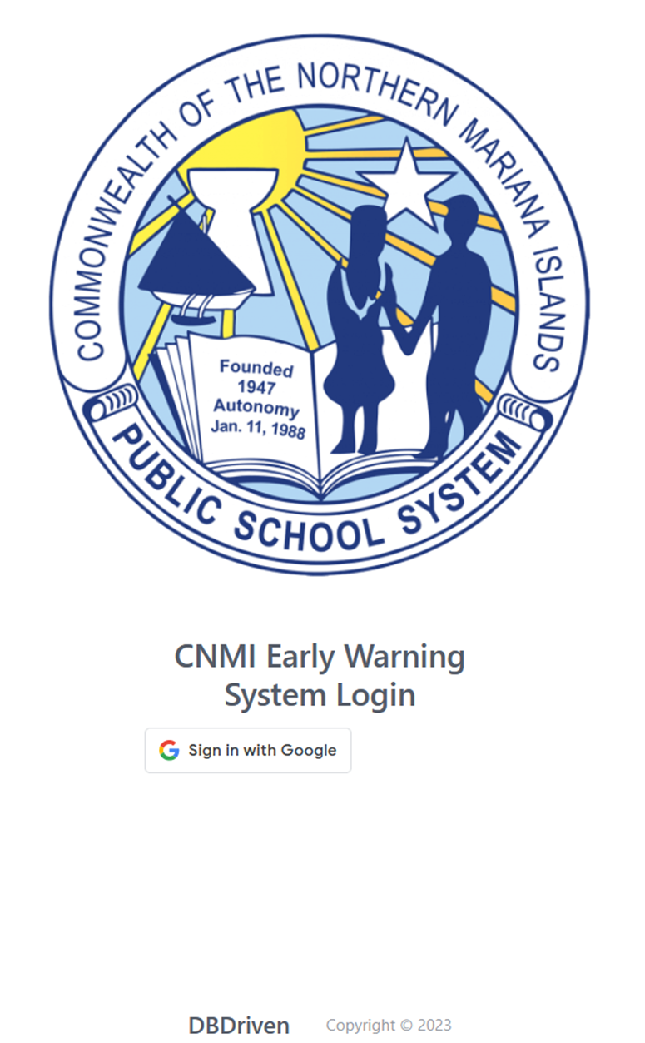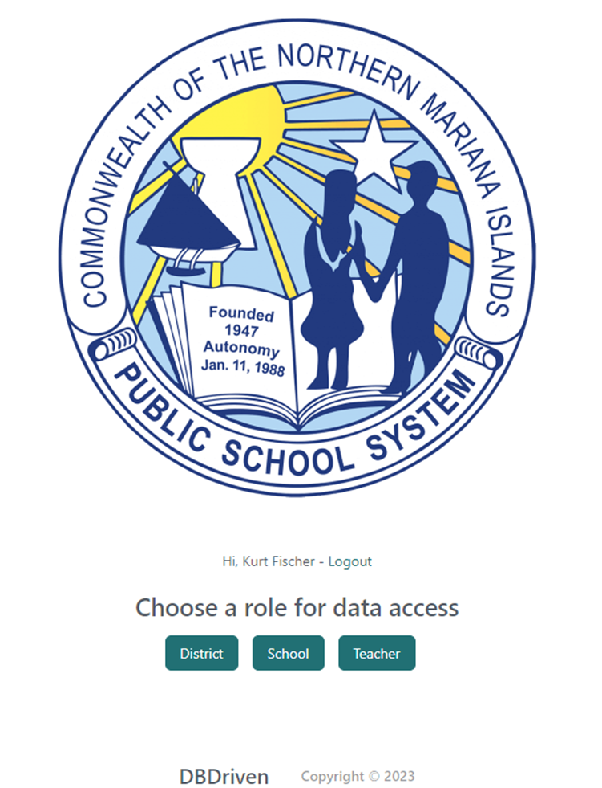Otherwise, the system defaults to the role assigned to the individual.

Figure : CNMI Early Warning System Login Page Figure : Multiple Roles Login Page

## Roles

Three roles are defined within the EWS.

1. District
2. School
3. Teacher

### District Role

District Administrative Staff will have access to all EWS components across all schools and students in the district.

### School Role

School Administrative Staff will only have access to the EWS component for all students at the specific school(s) they are assigned.

### Teacher Role

School Teachers will only have access to the EWS component for students in their course(s) at the specific school(s) they are assigned.

# EWS Features

The EWS leverages the interactive functionality of custom dynamic report features to visually present the early warning data to users on a report page. The page facilitates the ability to select filters to manipulate the visuals on data points. Visuals on the reports reflect the student data in terms of total counts of students triggering risk indicators or categorized as On Track or Early Warning. The counts adjust based on applied filters.

Data points included in the EWS filters include school year, schools, student attributes (e.g. Title I, ELL, Head Start, IEP), and risk indicators (i.e. attendance, behavior, assessments, etc.). Filters are dependent on your role, so for example, only a user with the District role will have a filter for all schools.

The Filters section (Figures 3 and 4) of the District and School reports displays the filters wherein business users may interact with and change the applied filters. Page level filters work on all visuals within one page of the report. If more than one filter is applied on a single page, the visuals will filter based on all criteria as applicable.

For example, selecting a school year in the “School Year” filter, a school name in the “School Name” filter, and a risk indicator in the “Risk Indicators” filter will display the selected school data for only the selected school year and risk indicator. A user may select multiple filter criteria. The more filters selected in combination together, the more restrictive the resultant data will be that the report returns. Once all filter criteria are selected, the user must select “**Submit**” in the Filters section to view the report results.

Figure : District Role Filters

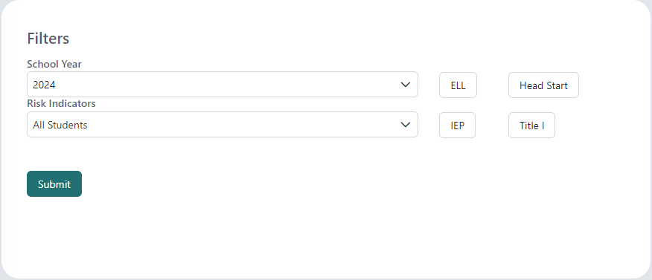

Figure : School Role Filters

## District Report

The District EWS Page provides a high-level perspective of EWS indicators organized for viewing and analysis by District personnel. The page includes analytics to compare and contrast CNMI PSS Schools. The District Page provides the ability to filter data based on demographics and other important data points detailed in the EWS Features, section 3.

The District Report displays student data for all schools. There are visuals displaying the count of students On Track and Early Warning, Students by School Year, Students by School, and Students by Risk Indicator. The visuals update based on selections from the Filters section.

Multiple Filters may be selected at the same time. Choose the desired filter(s) and click “Submit” to update the visuals. To update or remove Filters, deselect the filter and click “Submit”. Visuals only update after clicking “Submit”.

The Students By Risk Indicator visual shows the count of students triggering each Risk Indicator. A single student may trigger more than one risk indicator, so the Risk Indicator visual reflects the total number of times a risk is triggered. All other visuals show the total count of students categorized as On Track or Early Warning.

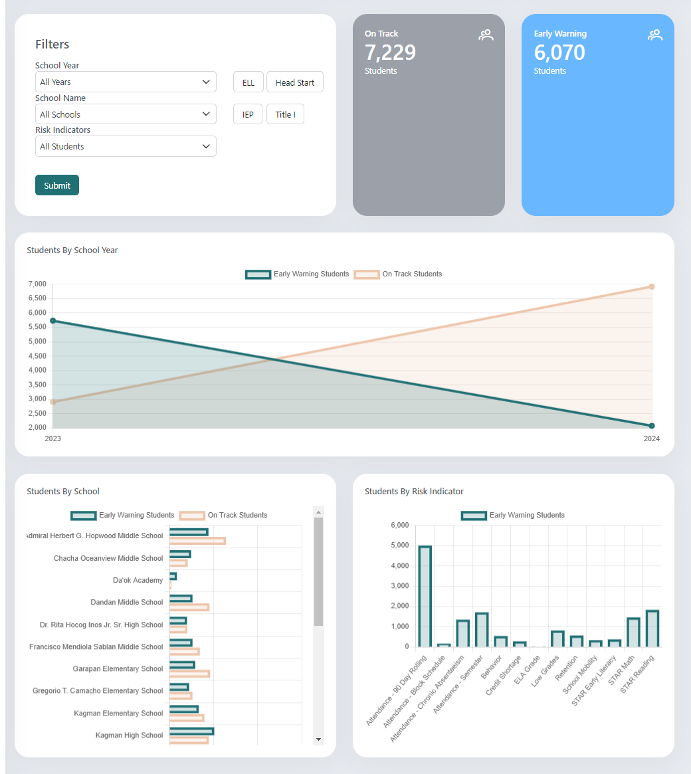

Figure : District Report

The District Report provides a menu on the left side of the page at the District level for a high-level overview, or to select a specific school to view the school’s School Report page (see the School Report, section 3.2, for details on the School Report). Hovering over the menu on the left expands the collapsed menu pane. Clicking the circle button at the top right of the menu freezes the menu in place, so it remains expanded without hovering over it.

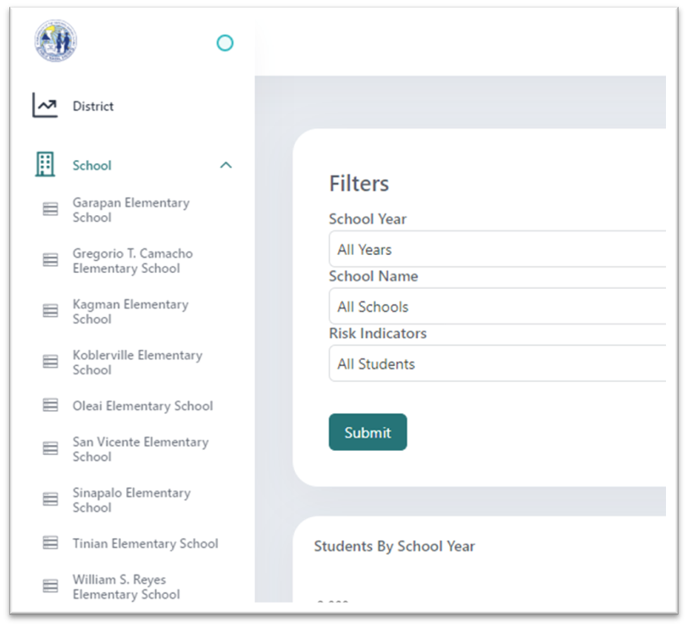

Figure 6: District Report Menu

When viewing a School Report page, the user may select a student in the Student Roster to view a student’s profile. See the Student Roster and Profile, section 3.4, for details on the Student Roster and Profile.

## School Report

The School Report provides a high-level perspective of EWS indicators organized for viewing and analysis by school personnel for a single school only. The School Report provides the ability to filter data based on demographics and other important data points detailed in the EWS Features, section 3.

The School Report displays student data for the count of students On Track and Early Warning by grade and for the Students by Risk Indicator. The Students by Risk Indicator visual shows the count of students triggering each Risk Indicator. A single student may trigger more than one risk indicator, so the Risk Indicator visual reflects the total number of times a risk is triggered. All other visuals show the total count of students categorized as On Track or Early Warning.

The visuals update based on selections from the Filters section. Multiple Filters may be selected at the same time. Choose the desired filter(s) and click “Submit” to update the visuals. To update or remove Filters, deselect the filter and click “Submit”. Visuals only update after clicking “**Submit**”.

When viewing a School Report page, the user may select a student in the Student Roster to view a student’s profile. See the Student Roster and Profile, section 3.4, for details on the Student Roster and Profile.

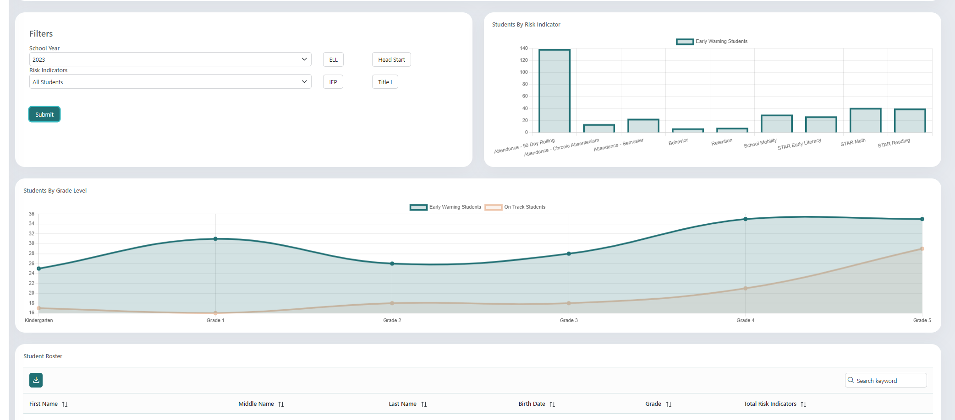

Figure : School Report

The School Report provides a menu on the left side of the page, if and only if, the user is assigned to more than one school. Hovering over the menu on the left expands the collapsed menu pane to show the assigned schools. Clicking the circle button at the top right of the menu freezes the menu in place, so it remains expanded without hovering over it.

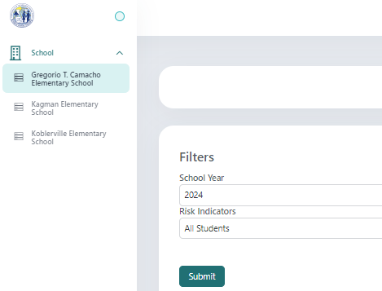

Figure : School Report Menu

## Teacher Report

The Teacher Report provides teachers with access to view each course and all the students they teach. The initial view for a teacher is a complete Student Roster of all the students they teach. Selecting a student in the Student Roster opens the student’s profile. See Student Roster and Profile, section 3.4, for details on the Student Roster and Profile.

The menu on the left side of the page facilitates the ability to select and view only the student data for the students in a specific course. If a teacher teaches at more than one school, then the menu displays the schools and courses assigned to the teacher. Hovering over the menu on the left expands the collapsed menu pane to show the assigned schools. Clicking the circle button at the top right of the menu freezes the menu in place, so it remains expanded without hovering over it.

Use the menu to choose the desired school (if applicable) and course to view (Figure 9). Selecting a course displays the course Information, Students by Risk Indicator, and the course’s Student Roster (Figure 10).

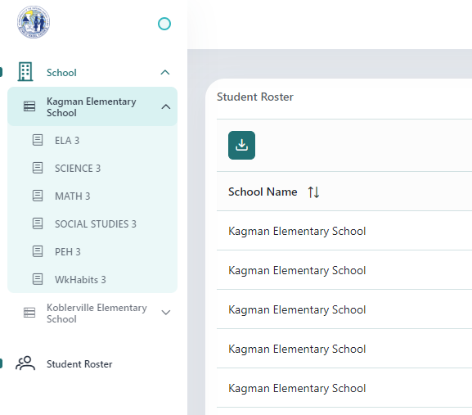

Figure : Teacher Report Menu

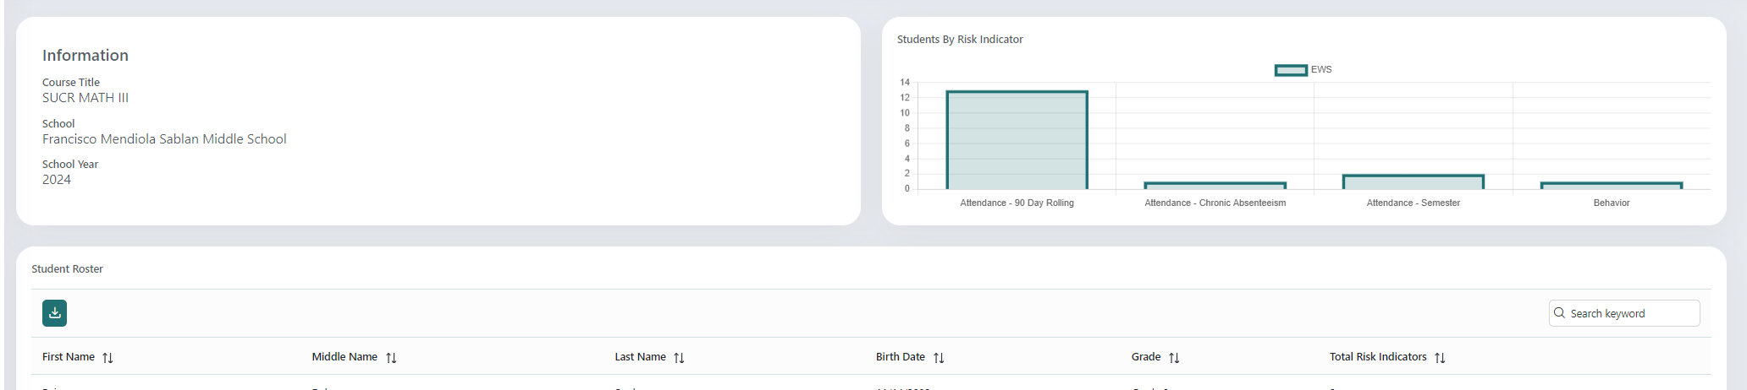

Figure : Course Report Page

## Student Roster and Profile

A Student Roster is available to District, School, and Teacher roles. A Student Roster shows basic information on the students within the school (district and school roles) or the course (teacher role) viewed. Any filters applied on a Student Roster page will filter the students displayed in the table. All columns in the Student Roster may be sorted by clicking the arrows next to the column name. The “Search keyword” field will filter for matches found in the First Name, Middle Name, Last Name, and/or Grade columns.

The number of results (rows in the Student Roster) per page may be changed by selecting the dropdown at the bottom of the page to select 10, 25 or 100 rows. A user may also select a specific page of student data or scroll using the left and right arrows. The green download button in the Student Roster section allows the user to export the current list of students to Excel.

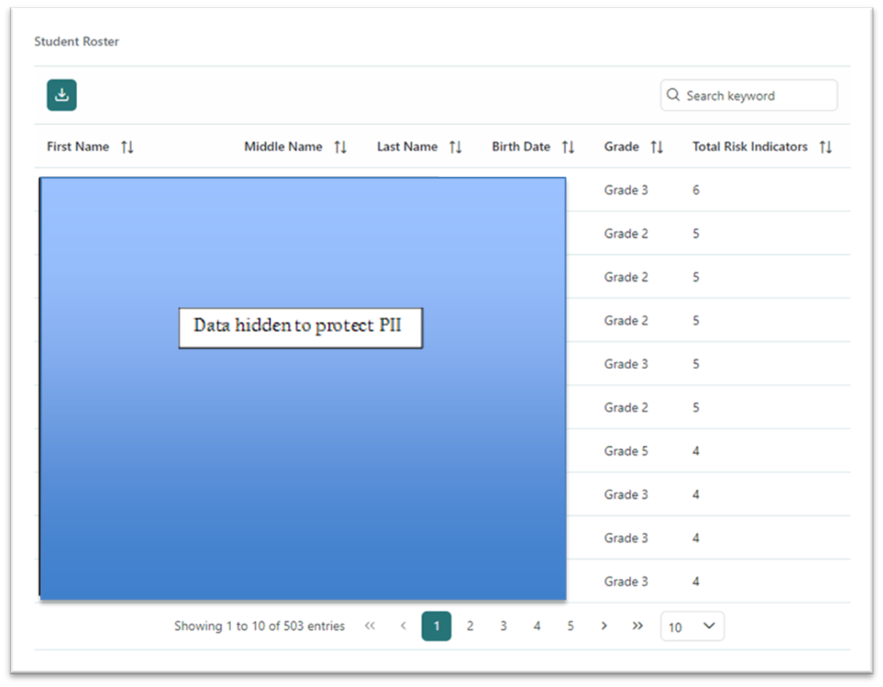

Figure : Student Roster

The Student Report view shows an in-depth look at an individual student profile and is available to District, School, and Teacher roles. The Student Report displays data for the selected student Information, On Track or Early Warning Status, Student Assessments, Early Warning Flags, and Interventions for the selected school year in the School Year filter.

The student Information includes any attributes of the student such as IEP, ELL, Title 1, and/or Head Start. The Status indicates whether the student’s status is On Track or Early Warning. A student’s status is set to Early Warning, if an indicator is triggered based on the business rules found in Indicator Business Rule, Score, Weight, section 4.2.

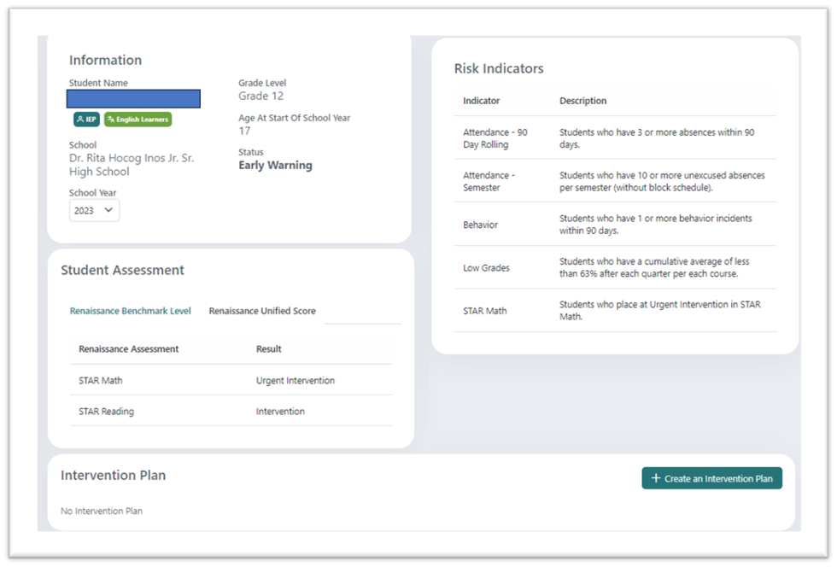

Figure 12: Student Report

The Student Assessment section displays the Renaissance Assessments taken and the respective Benchmark Levels and Unified Scores on separate tabs. The Benchmark Levels are documented as Urgent Intervention, Intervention, On Watch, or At/Above Benchmark. The Unified Score tab displays the Unified Score for each of the Renaissance Assessments as seen in Figure 13.

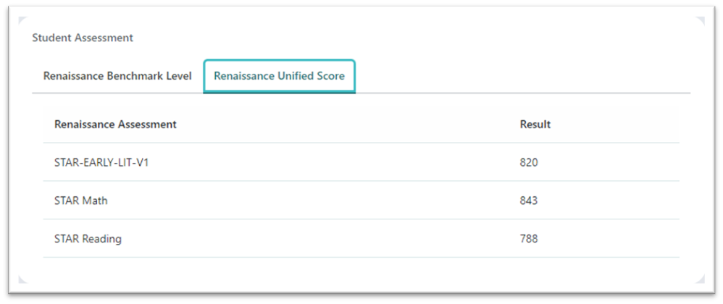

Figure 13: Student Assessment - Renaissance Unified Score tab

The Risk Indicators display each Indicator and business rule Description a student triggered. Indicators are listed in a student’s profile, if the business rules for an indicator are met. An Indicator may be selected from the list to display the associated events documented for a student as shown in Figure 14. Sorting is available by clicking the arrows next to the column names as well as the option to navigate through the pages of events.

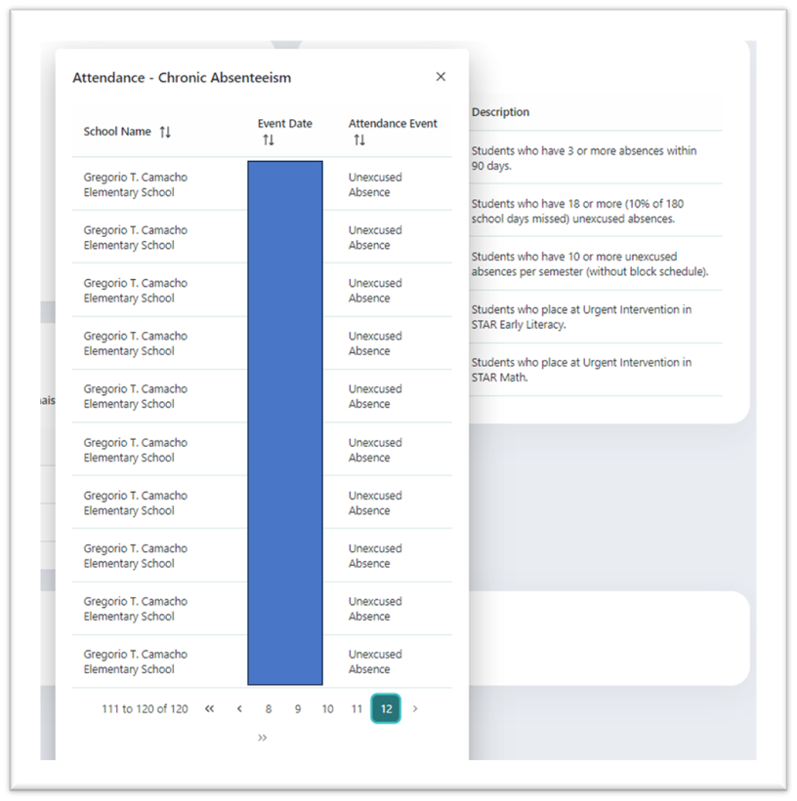

Figure 14: Example Risk Indicator Events

The last section in a student’s profile is the Intervention Plan. An Intervention Plan and associated Interventions are displayed in this section, if a school administrator or teacher enters one for a student. See Intervention Plan, section 3.5, for details.

## Intervention Plan

The EWS enables educators to record, track, and analyze the impact of mitigating actions — interventions and outcomes — in response to information from the indicators. School administrative staff and teachers may create an intervention plan as well as submit an intervention in a student’s profile. District administrative staff have read-only permission to view student interventions.

An Intervention Plan is specific to one school year only, and a new Intervention Plan must be created each new school year (if applicable). Past Intervention Plans and student interventions may be viewed in a student profile by selecting a School Year as shown in the Information section of Figure 12.

To create an intervention plan, navigate to the student roster and select a student profile. In the Intervention Plan section of the student profile, select the green ‘+ Create an Intervention Plan’ button.

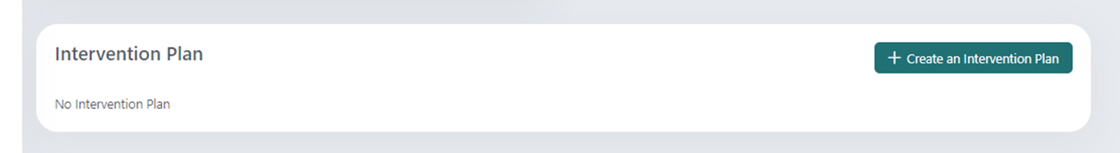

Figure : Create an Intervention Plan

The following box will open to add information on the Student’s Background, Goal(s) of the Intervention Plan, and the Student’s Progress. The Goal text box is a required field denoted by the asterisk and red box. Click ‘Submit’ when finished.

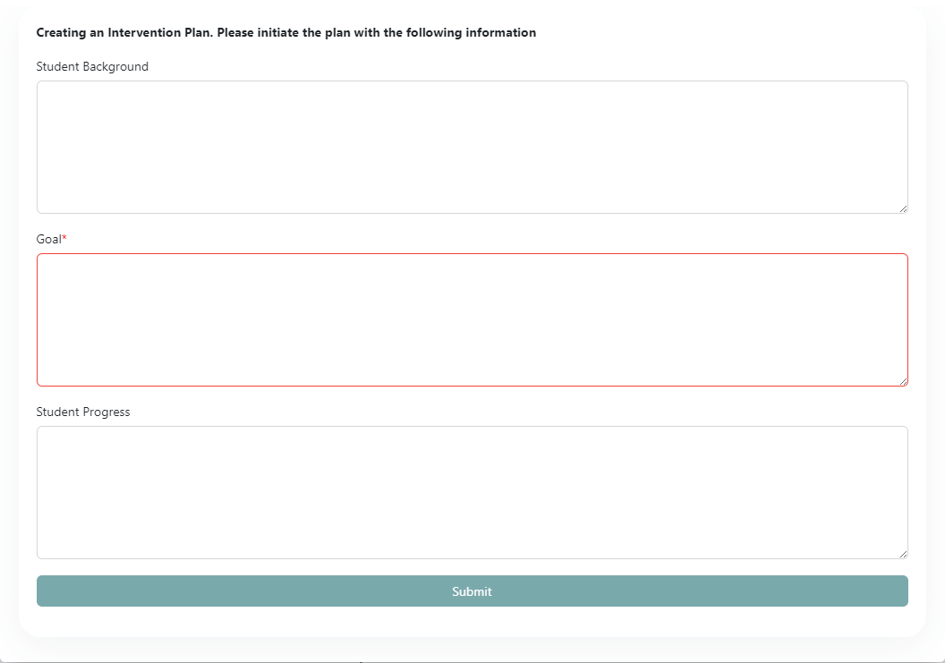

Figure : Submit an Intervention Plan

A submitted Intervention Plan may be edited by selecting the ‘+ Edit Plan Initial Details’ button. Editing the Plan Details allows the user to add/update the Student Background, Goal, and Student Progress fields in Figure 15. Additionally, once an Intervention Plan is created, a student intervention may be entered by selecting the ‘+ Submit Intervention’ button.

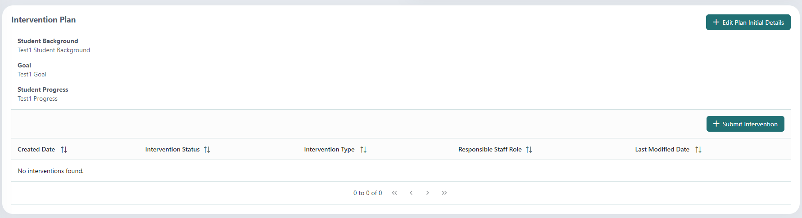

Figure : Intervention Plan Details

The following image shows the available fields to submit a student intervention. The status of “New” is the default value to initially submit a student intervention. The status is changed by selecting the intervention after it is submitted.

The dropdown menu for Intervention Type provides a list of pre-loaded interventions to assign to a student. To enter more than one intervention type, complete and submit a separate student intervention. The dropdown menu for the Responsible Role provides a list of staff roles to assign a member to monitor the intervention.

A Start Date is required to document when the intervention will start. The End Date may be entered at any time to document the end of the student intervention. Comments are optional. Selecting “Submit” displays the intervention in a list as shown in Figure 19.

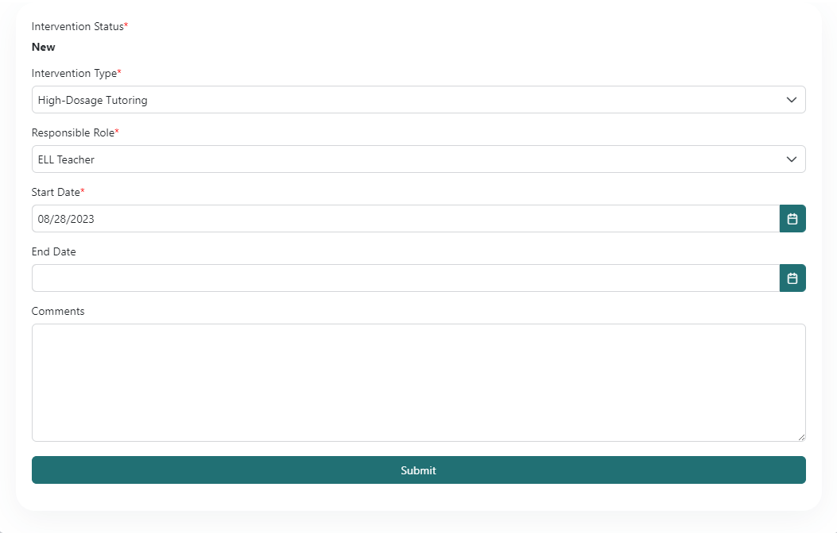

Figure : Submit an Intervention

Select a listed student intervention to view the details.

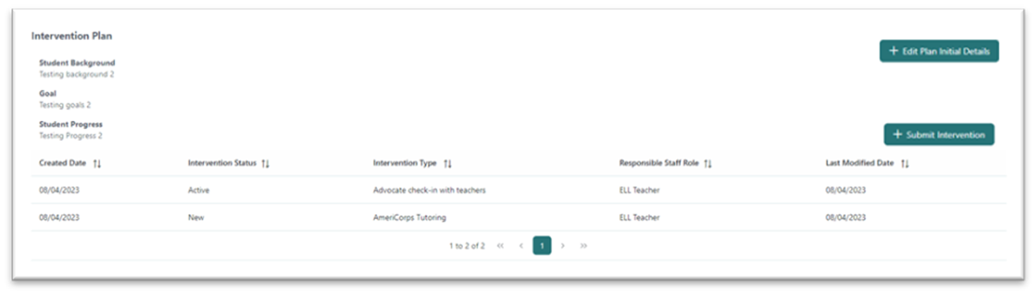

Figure : Example Student Intervention Input

# EWS Data and Business Rules

This section details the data sources, type of data, and the data refresh rates. The primary data provider for the EWS solution is the K12 SLDS. Data is sourced from the Student Information Systems and the Reading and Math Assessment system.

This section also details business rules for the EWS Solution to include flags and indicators, scoring, scoring weights, thresholds, and references. The purpose is to provide educators with measurable data over time for individual students and student groups. Indicators are quantifiable measures of behaviors, skills, and characteristics that are highly predictive of students’ success. Indicators are limited to the most valuable (a few good indicators are more actionable than many). Thresholds that indicate the type of action needed — indicating whether to take action now, not yet, or not at all — may vary by context, but will fall within a numerical range established by evidence.

## Data Sources and Refresh Rate

Student information updates are provided nightly to the EWS from the SLDS. Assessment data is provided monthly. Internal EWS feedback data is updated real-time upon data entry.

| **ID** | **Agent** | **Data Coming From Data Source** |
| --- | --- | --- |
| DF1 | ChildPlus | Preschool Experiences |
| DF2 | Infinite Campus | Name Grade Level Discipline ELA Grade Credits Earned  Attendance SpEd Mobility ELL Retention |
| DF3 | Renaissance | STAR Early Literacy STAR Reading STAR Math |
| DF4 | EWS | Feedback entered by CNMI PSS staff on student intervention actions |

Table : Data Sources

| **ID** | **Dataflow Name** | **Dataflow Description** | **Refresh Rate** |
| --- | --- | --- | --- |
| DD1 | ChildPlus | Refresh of pre-school/kindergarten data | Nightly |
| DD2 | Infinite Campus | Refresh of K-12 data | Nightly |
| DD3 | Renaissance | Refresh of STAR Assessment data | Monthly |

Table : Data Refresh Rate

## Indicator Business Rules

CNMI stakeholders have provided a set of business rules (defined as indicators) to determine the criteria for setting a flag on a target population which is screened through the EWS. The target population is screened for every indicator provided and results stored in the EWS Solution. Each indicator is further defined by its unit of measure. For example, if the attendance indicator is 3 or more absences within the last 90 days, then the unit of measure is “number/frequency of absences within 90 days”.

|  |  |  |  |
| --- | --- | --- | --- |
| **ID** | **Indicator** | **Business Rule Description** | **Note** |
| BR1 | Attendance - 90 Day Rolling | Students who have 3 or more absences within 90 days. Every Unexcused Absence is counted.  number/frequency of absences per 90 day period | Elem, MS, HS |
| BR2 | Attendance - Semester | Students who have 10 or more unexcused absences per semester (without block schedule) | Elem, MS, HS |
| BR3 | Attendance - Block Schedule | Students who have 5 or more unexcused absences per semester (for block schedule) | Cha Cha MS only |
| BR4 | Attendance - Chronic Absenteeism | Students who have 18 or more (10% of 180 school days missed) unexcused absences | Elem, MS, HS |
| BR5 | Behavior | Students who have 1 or more behavior incidents within 90 days | >1 office referrals |
| BR6 | STAR Early Literacy | Students who place at Urgent Intervention in STAR Early Literacy | ‘RenaissanceBenchmarkCategoryName’ |
| BR7 | STAR Reading | Students who place at Urgent Intervention in STAR Reading | ‘RenaissanceBenchmarkCategoryName’ |
| BR8 | STAR Math | Students who place at Urgent Intervention in STAR Math | ‘RenaissanceBenchmarkCategoryName’ |
| BR9 | ELA | Students who score a 1 or 2 |  |
| BR10 | Math Grade | Students who score a 1 or 2 |  |
| BR11 | School Mobility | Students who have attended 2 or more elementary schools between kindergarten and 5th grade. School Mobility is evaluated by any school move in the previous or current school year. Ignore summer sessions. |  |
| BR12 | Retention | An indicator (flag) on whether the student has been retained |  |
| BR13 | Low Grades | Students who have a score <63% for any course at the end of the 1st Quarter or the cumulative average after each quarter. | MS, HS only |

|  |  |  |  |
| --- | --- | --- | --- |
| **ID** | **Indicator** | **Business Rule Description** | **Note** |
| BR14 | Credit Shortage | <4 credits earned by the end of 1st semester of 9th grade.  <7 credits earned by the end of 2nd semester of 9th grade.  <10 credits earned by the end of 1st semester of 10th grade.  <14 credits earned by the end of 2nd semester of 10th grade.  <17 credits earned by the end of 1st semester of 11th grade.  <21 credits earned by the end of 2nd semester of 11th grade.  <24 credits earned by the end of 1st semester of 12th grade.  <28 credits earned by the end of 2nd semester of 12th grade. | HS only |

Table : Indicator Business Rules

## Student Attribute Table

In addition to the indicator business rules to flag students at risk, student attributes are defined as follows to identify groups of students.

|  |  |  |
| --- | --- | --- |
| **ID** | **Attribute** | **Business Rule Description** |
| AT1 | Preschool experience | Student attribute if attended early head start or head start. This data is sourced from ChildPlus. |
| AT2 | Special Education | Student attribute if in Individualized Education Program (IEP) |
| AT3 | English Learner | Student attribute if enrolled/designated an English Learner (ELL) |
| AT4 | Title 1 | Student attribute if designated as Title I |

Table : Student Attributes