DB Driven, LLC

100 Riverside Parkway

Fredericksburg, VA 22406

CNMI PSS Monthly Status report

1 – 30 April 2023

Table of Contents and Figures

Table of Contents and Figures 1

Monthly Status Report 2

Onboard P20W Data Sets as needed 2

Ongoing Support Services 2

System Maintenance and Performance Tuning 3

Figure 2: CNMI Data Source Ingestion and Mapping 4

Figure 3: CNMI PSS SLDS & P20W Infrastructure Status 5

Figure 4: CNMI PSS SLDS & P20W Data Pipeline Status 6

1.1 Project Management Events 7

1.2 Infrastructure Events 9

1.3 Development Events 9

1.4 Azure Dev Ops Events 10

## **Monthly Status Report**

This document provides the Monthly Status Report for the Period 1-30 April 2023. This monthly status report is Deliverable # 19 of the PSS Contract Number 165567 - OC.

## **Onboard P20W Data Sets as needed**

To date, all CNMI data sources have been ingested into the CNMI Multi-year data warehouse. DBDriven processes provide daily updates and ingestion of CNMI PSS data into the K12 SLDS.

## **Ongoing Support Services**

DBDriven performed the following support services during Aprl 2023.

* Continued development of the School Report Card.
* Completed 508 compliance review and updates to the School Report Card and posted new report at the Test URL.
* Completed development of the Facts and Figures report and posted an updated report at the Test URL.
  + [FF_Report_Aggregate - Power BI Report Server (slds.solutions)](https://powerbi-t.slds.solutions/ReportsPowerbi-t/powerbi/CNMI/FF_Report_Aggregate)
* Working with AEM to review Generate 5.3 configuration and issues. Continued testing for C129.
* Continued testing the 27 EdFacts reports in Generate 5.3 with AEM data.
* Continued testing the C002, C029, C033, C039, C052, C059, C089, and C129 in Generate 5w with CNMI data.
* Continued development of the landing pages for the EWS.
* Developed an EWS presentation and video for use by CNMI.
* Continued build-out of the Test and Production cloud environments (infrastructure).
  + Successfully installed and configured the API copy utility into Production. All data is now present in the Production environment.
  + Continued configuration of the P20W CRM solution (development).
  + Continued development of the workflow queuing, which affects amendments, catalogs, and research purposes.
  + Continued development work on the CRM proxy services.
  + Continued Dev testing of the P20W data components in the Test Environment, to include the Data Manager, Data Hub and Data Adapter.
* Monitored synchronization of the 2023 Single Year.
* Successfully initiated and completed testing of the manual Ed-Fi Data Import process to the MultiYear Production cloud environment.
* Continued coordination with CIID to troubleshoot use of Active Directory with Generate in the Azure cloud environment.
* Continued work on automating the synchronization of 2023 Child+ data into Production. Complete and submitted the AWS VPN survey.
* Updated the 2023 Child+ data into the Production environment.
* Developed hierarchical structure for Job Types to support reporting.
* Initiated and continued mapping of Job Types to Job Categories.
* Updated Smarty Ants, Achieve 3000, SBA, TS-GOLD, MSAA, AP and WIDA assessment data in the warehouse.
* Conducted PM status meeting with CNMI representatives 4 Apr ChST.
* Conducted PM status meeting with CNMI representatives 17 Apr ChST
* Submitted Deliverable #18 March on 7 Apr

## **System Maintenance and Performance Tuning**

Figure 2 provides the status of CNMI PSS system data. Depending on the data source, data is ingested daily, monthly, quarterly, or annually. During this period, DBDriven provided ongoing maintenance and tuning of each data source and the collective data repositories within each environment (Development, Test, Production).

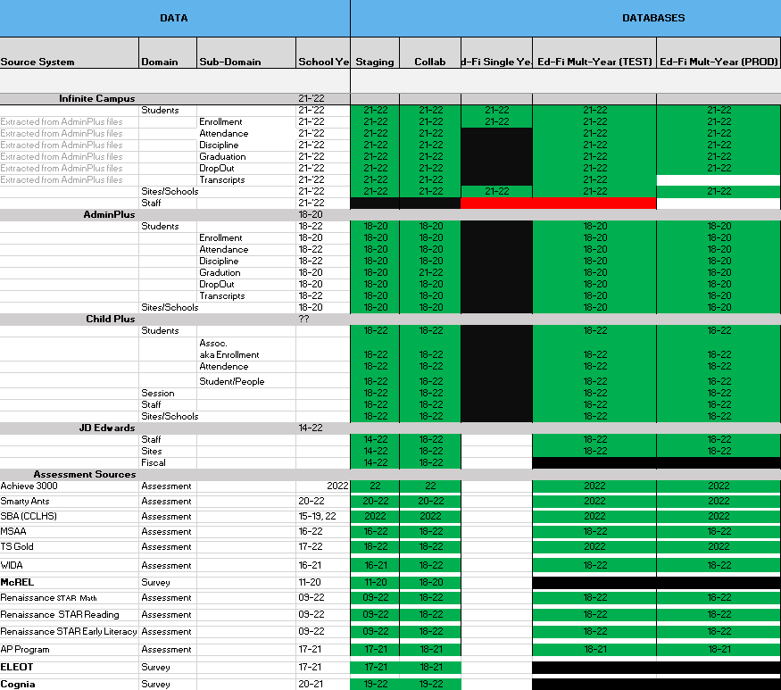

Figure 2: CNMI Data Source Ingestion and Mapping

DBDriven continues efforts to build, tune and configure the Development, Test and Production environments for the K12 SLDS, P20W and EWS.

Figure 3 provides the state of the CNMI PSS hosting physical environment.

Figure 3: CNMI PSS SLDS & P20W Infrastructure Status

Figure 4 provides the state of the CNMI PSS data environments and components.

Figure 4: CNMI PSS SLDS & P20W Data Pipeline Status

## **Project Management Events**

## **Infrastructure Events**

## **Development Events**

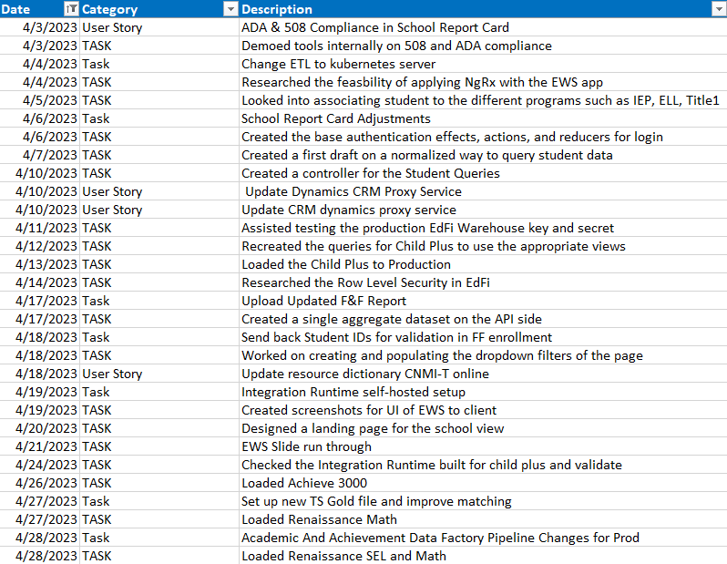

## **Azure Dev Ops Events**

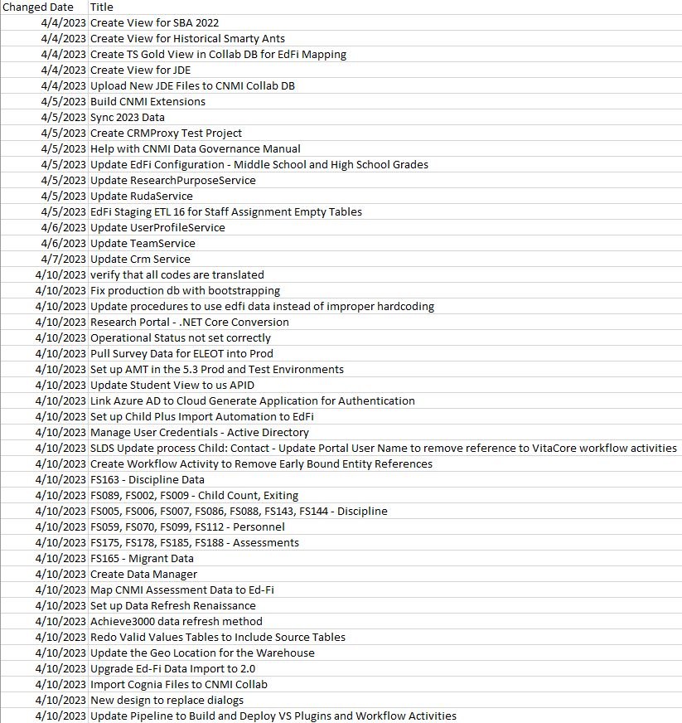

ADO Cont’d

