DB Driven, LLC
100 Riverside Parkway
Fredericksburg, VA 22406
CNMI PSS Monthly Status report
1 – 31 August 2023

Table of Contents and Figures
Table of Contents and Figures 1
Monthly Status Report 2
Onboard P20W Data Sets as needed 2
Ongoing Support Services 2
1.1 System Maintenance and Performance Tuning 4
Figure 2: CNMI Data Source Ingestion and Mapping 4
Figure 3: CNMI PSS SLDS & P20W Infrastructure Status 5
Figure 4: CNMI PSS SLDS & P20W Data Pipeline Status 6
1.2 Project Management Events 7
1.3 Infrastructure Events 11
1.4 Development Events 11
1.5 Azure Dev Ops Events 12

Monthly Status Report
This document provides the Monthly Status Report for the Period 1-31 August 2023. This monthly status report is Deliverable # 23 of the PSS Contract Number 165567 - OC.

Onboard P20W Data Sets as needed
To date, all CNMI data sources have been ingested into the CNMI Multi-year data warehouse. DBDriven processes provide daily updates and ingestion of CNMI PSS data into the K12 SLDS.

Ongoing Support Services
DBDriven performed the following support services during August 2023.

- Participated in the NCES STATS-DC Conference in Bethesda, MD during 9-11 August.
- Conducted a detailed review of the CNMI dashboard feedback on 14-15 August.
- Provided a first look of the Administrative Dashboard to CNMI representatives (Jeaniffer and Annette) on 15 August.
- Successfully completed User Acceptance Testing (UAT) for the Early Warning System (EWS) Pushed EWS to Production environment.
- Delivered the EWS user manual.
- Monitored the EWS Production environment.
- Delivered an updated Technical Design document.
- Completed updates to the School Report Card.
- Received remaining SY22-23 Assessment data. All 22-23 assessment data has been loaded to the multi-year data warehouse.
- Recreated 2023 Infinite Campus Staging Connection to EdFi Single Year Test Database.
- Monitored synchronization of SY2023 data to EdFi Single Year Test Database.
- Created 2024 Infinite Campus Connection to EdFi Single Year Database in Staging and Production environments.
- Monitored synchronization of the 2023-24 Single Year Production Database.
- Establishment of the live connection to the ChildPlus Amazon Web Services (AWS) production and test databases.
- Continued build-out of the Test and Production cloud environments (infrastructure).
  - Continued configuration of the P20W CRM solution (development).
- Continued development on the P-20W solution.
- Contacted Dave Gau (ShaveFX) for a price quote on the P20W About and Security videos.
- Troubleshooting and coordination with CNMI and CIID with the FS052 (Membership) report.
- Continued coordination with AEM regarding issues with the FS052 (Membership) report.
- Initiated review of the Jan and Feb EdFacts Reports.
- Participated in the Technical call on 2 Aug (ChST).
- Participated in the Project Update call on 3 Aug (ChST).
- Participated in the Project Management and Technical calls on 8 Aug (ChST).
- Conducted P20W Training on 15 - 16 Aug (ChST)
- Participated in the Technical call on 15 Aug (ChST).
- Participated in the Project Management and Technical calls on 22 Aug (ChST).
- Participated in the Project Management and Technical calls on 29 Aug (ChST).
- DW Mapping, Extraction and Transformation (ongoing).

System Maintenance and Performance Tuning
Figure 2 provides the status of CNMI PSS system data. Depending on the data source, data is ingested daily, monthly, quarterly, or annually.

During this period, DBDriven provided ongoing maintenance and tuning of each data source and the collective data repositories within each environment (Development, Test, Production).

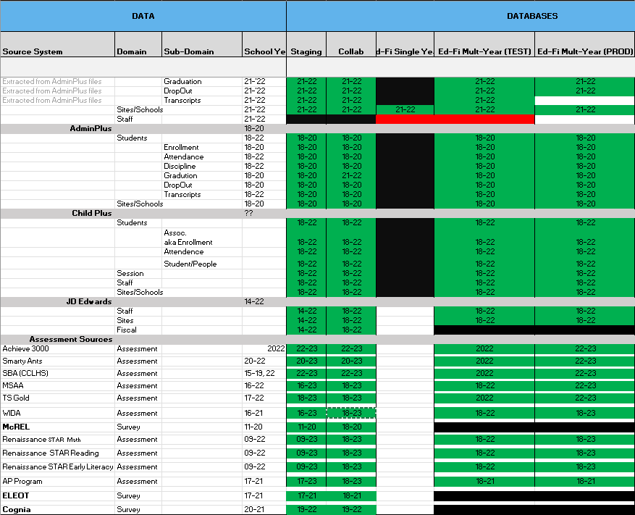
Figure 2: CNMI Data Source Ingestion and Mapping

DBDriven continues efforts to build, tune and configure the Development, Test and Production environments for the K12 SLDS, P20W and EWS.

Figure 3 provides the state of the CNMI PSS hosting physical environment.

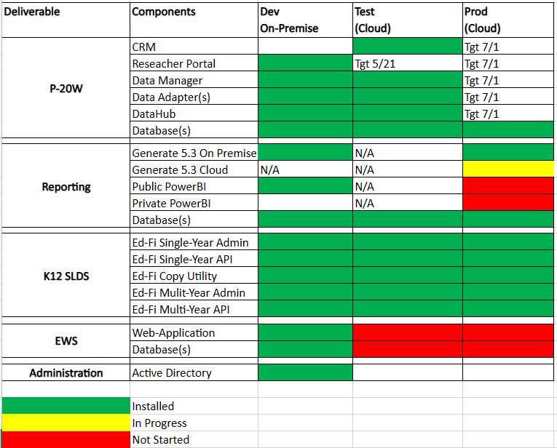
Figure 3: CNMI PSS SLDS & P20W Infrastructure Status

Figure 4 provides the state of Generate Test Results.

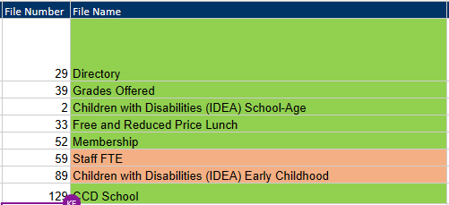

Figure 5 provides the state of the CNMI PSS data environments and components.

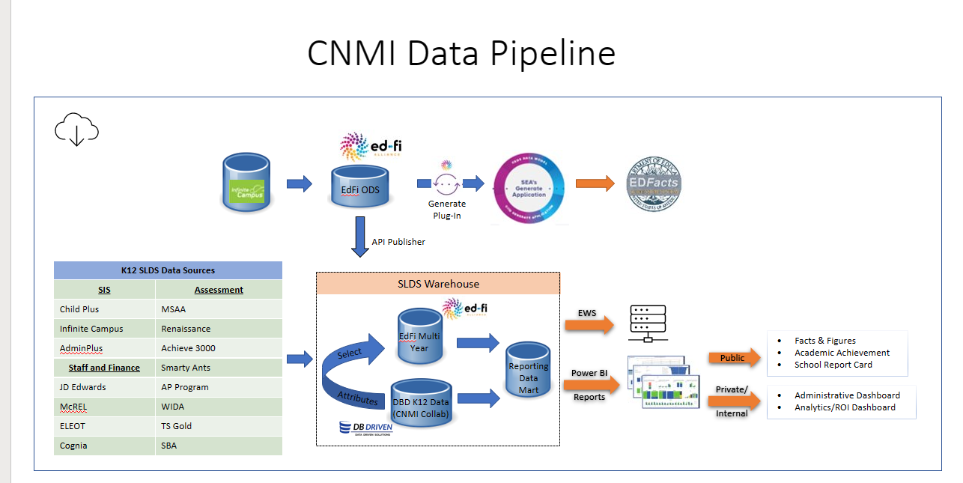
Figure 4: CNMI PSS SLDS & P20W Data Pipeline Status

Project Management Events

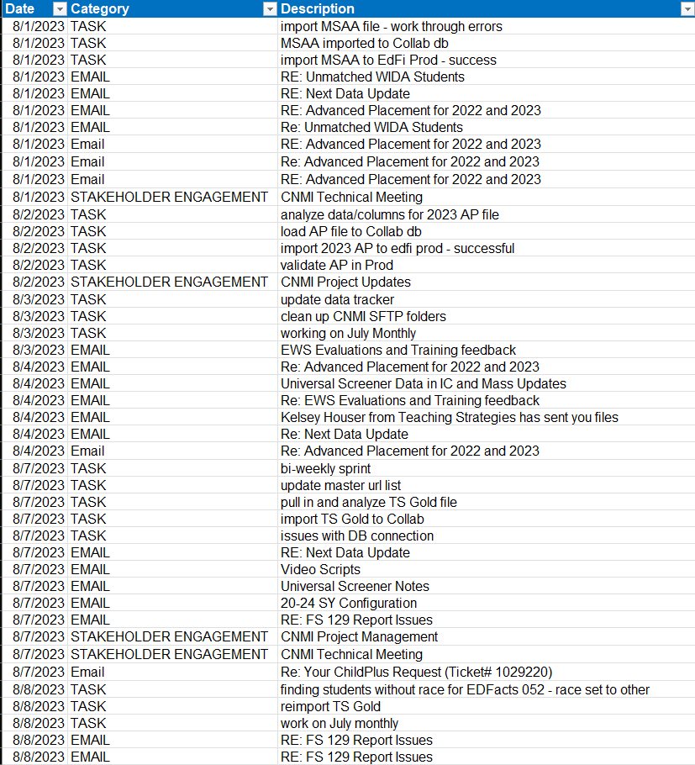

Project Management Cont’d

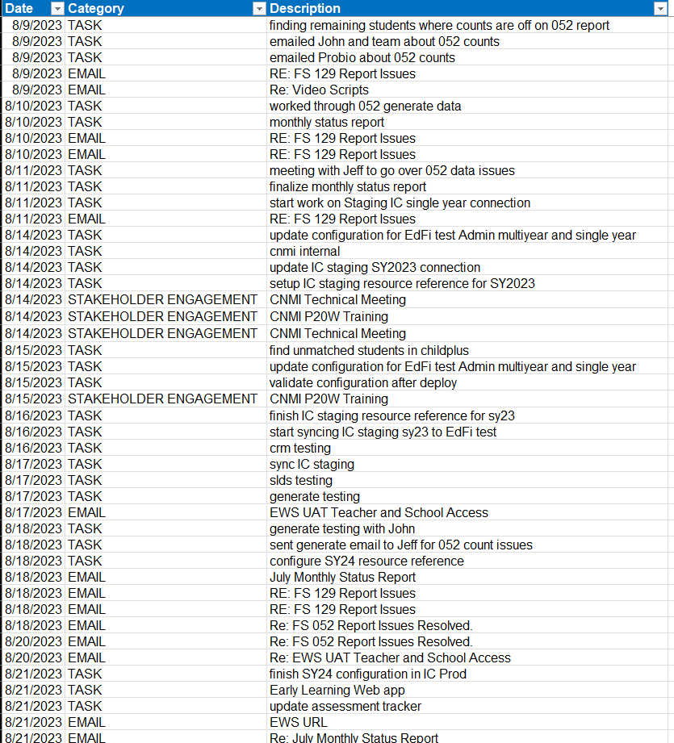

Project Management Cont’d

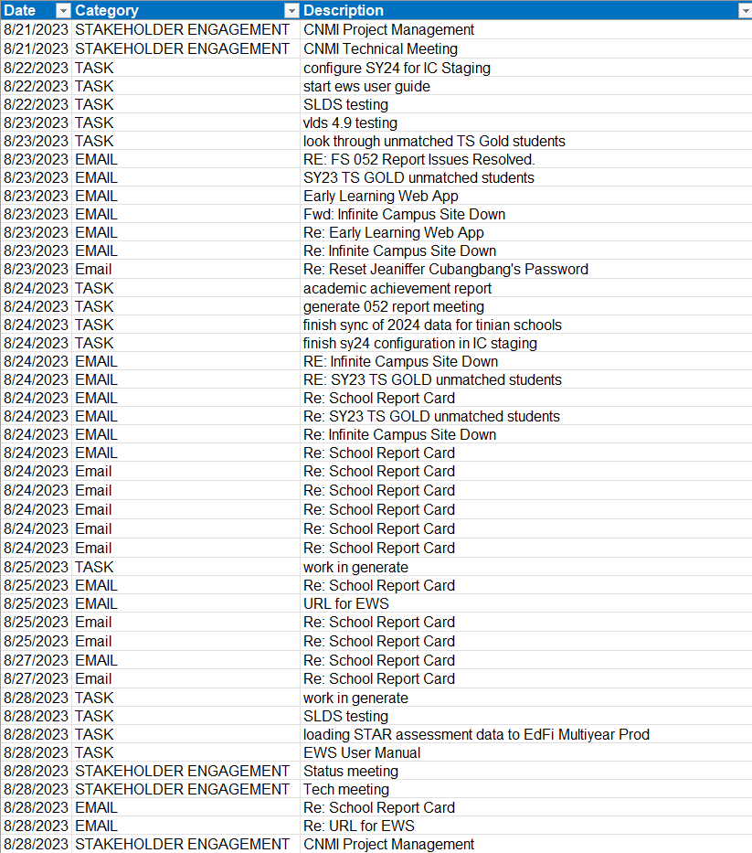

Project Management Cont’d

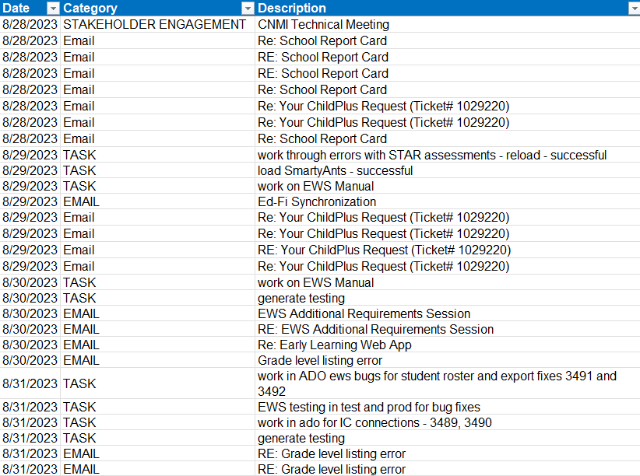

Infrastructure Events

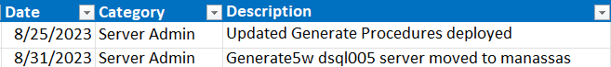

Development Events

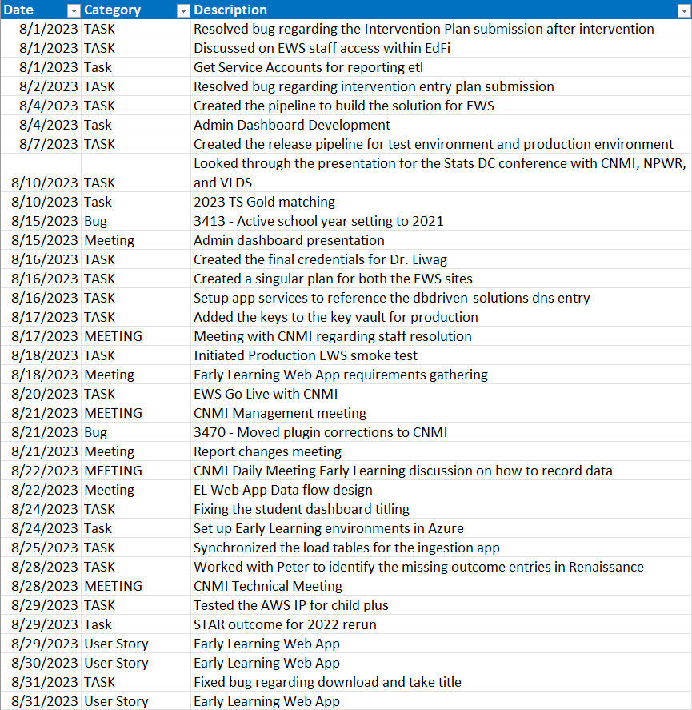

Azure Dev Ops Events

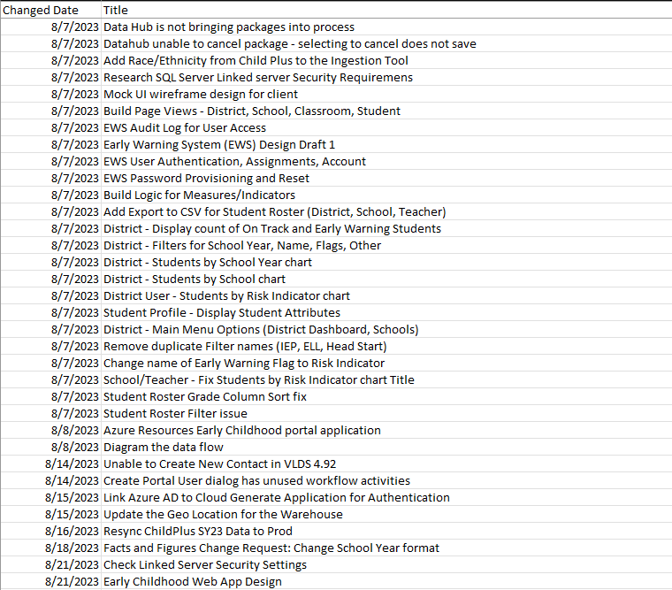

AZURE DEV OPS Cont’d

