DB Driven, LLC

100 Riverside Parkway

Fredericksburg, VA 22406

CNMI PSS Monthly Status report

1 – 31 December 2023

Table of Contents and Figures

Table of Contents and Figures 1

Monthly Status Report 2

Onboard P20W Data Sets as needed 2

Ongoing Support Services 2

1.1 System Maintenance and Performance Tuning 3

Figure 2: CNMI Data Source Ingestion and Mapping 3

Figure 3: CNMI PSS SLDS & P20W Infrastructure Status 4

Figure 4: CNMI PSS SLDS & P20W Data Pipeline Status 6

1.2 Project Management Events 7

1.3 Infrastructure Events 10

1.4 Development Events 11

1.5 Azure Dev Ops Events 12

## **Monthly Status Report**

This document provides the Monthly Status Report for the Period 1-31 December 2023. This monthly status report is Deliverable # 27 of the PSS Contract Number 165567 - OC.

## **Onboard P20W Data Sets as needed**

To date, all CNMI data sources have been ingested into the CNMI Multi-year data warehouse. DBDriven processes provide daily updates and ingestion of CNMI PSS data into the K12 SLDS.

## **Ongoing Support Services**

DBDriven performed the following support services during December 2023.

* Continued testing the P-20W solution CRM, Researcher Portal, Data Dictionary and Data Request Tool.
* Updated components with CNMI logo and language.
* Emailed Middle and High School EWS UAT Users the test scripts and user guide.
* Awaiting Middle and High School EWS UAT Users the test scripts.
* Processed and responded to Middle and High School EWS UAT Users test scripts.
* Monitored the EWS.
* Monitored synchronization of the 2023-24 Single Year.
* Continued troubleshooting the Generate application and EdFacts reports.
* Requested a discussion on the use of Generate to create the EdPass submissions.
* Began analyzing the FS175, FS178, FS185 and FS188 EdFacts reports. CNMI requested DBDriven support the EdFacts submission file process. These reports are not currently working in the Generate application and they are due January 10, 2024.
* Finalized PowerBI access and MFA configurations for the Administrative Dashboard.
* Sent an access instructions email to users of the Administration Dashboard. This report is now accessible in the Production environment.
* Submitted the invoice for Deliverable #13 Early Warning web application.
* Provided security documentation as requested.
* Provided count by school, grade, gender and ethnicity.
* Submitted the Monthly O&M Invoice.
* Participated in the Project Management and Technical calls on 5 Dec (ChST).
* Participated in the Project Management and Technical calls on 12 Dec (ChST).
* Participated in the Project Management and Technical calls on 19 Dec (ChST).

## **System Maintenance and Performance Tuning**

Figure 1 provides the status of CNMI PSS system data. Depending on the data source, data is ingested daily, monthly, quarterly, or annually.

During this period, DBDriven provided ongoing maintenance and tuning of each data source and the collective data repositories within each environment (Development, Test, Production).

Figure 1: CNMI Data Source Ingestion and Mapping

DBDriven continues efforts to build, tune and configure the Development, Test and Production environments for the K12 SLDS, P20W and EWS.

Figure 2 provides the state of the CNMI PSS hosting physical environment.

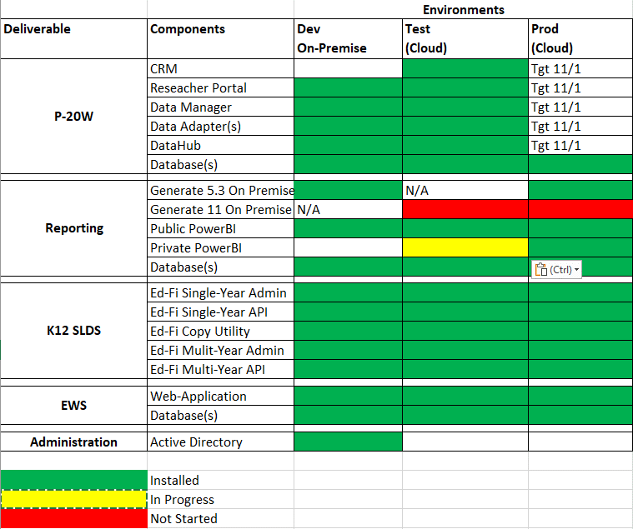

Figure 2: CNMI PSS SLDS & P20W Infrastructure Status

Figure 3 provides the state of Generate 5.3 Test Results.

Figure 3: Generate 5.3 Test Results

Figure 4 provides the state of Generate 11.0 Test Results.

Figure 4: Generate 11.0 Test Results

Figure 5 provides the state of the CNMI PSS data environments and components.

Figure 5: CNMI PSS SLDS & P20W Data Pipeline Status

## **Project Management Events**

Project Management Cont’d

Project Management Cont’d

## **Infrastructure Events**

## **Development Events**

## **Azure Dev Ops Events**

