DB Driven, LLC

100 Riverside Parkway

Fredericksburg, VA 22406

CNMI PSS Monthly Status report

1 – 28 February 2023

Table of Contents and Figures

Table of Contents and Figures 1

Monthly Status Report 2

Onboard P20W Data Sets as needed 2

Figure 1: EdFi SqlData Dictionary 2

Ongoing Support Services 2

System Maintenance and Performance Tuning 3

Figure 2: CNMI Data Source Ingestion and Mapping 4

Figure 3: CNMI PSS SLDS & P20W Infrastructure Status 5

Figure 4: CNMI PSS SLDS & P20W Data Pipeline Status 6

## **Monthly Status Report**

This document provides the Monthly Status Report for the Period 1-28 February 2023. This monthly status report is Deliverable # 17 of the PSS Contract Number 165567 - OC.

## **Onboard P20W Data Sets as needed**

To date, all CNMI data sources have been ingested into the CNMI Multi-year data warehouse. DBDriven processes provide daily updates and ingestion of CNMI PSS data into the K12 SLDS.

DBDriven provided CNMI with a list of 2,493 possible K12 data elements to be exposed to the P20W solution on Jan 25, 2023. Figure 1 is a snapshot of the elements provided for CNMI review.

Figure 1: EdFi SqlData Dictionary

## **Ongoing Support Services**

DBDriven performed the following support services during February 2023.

* Continued development and configuration of the P20W CRM solution and created the Azure Test environment instance.
* Continued build-out of the Test and Production cloud environments (infrastructure).
* Installed Generate 5.3 and conducted testing for C029, C039, C052 and C059. DBDriven was unable to produce the reports with Ver 5.3. Technical meeting with AEM scheduled for 28 Feb (EST).
* Met with CIID on Generate 5.3 testing to troubleshoot FS029 (Directory)
* Conducted internal reviews of the Facts & Figures report.
* Continued design and development for the Facts & Figures report.
* Updated the Facts & Figures report to use aggregate tables.
* Updated the School Report Card to use aggregated data and implemented changes requested by CNMI.
* Continued analysis of JD Edwards financial data.
* JD Edwards Financial data session with CNMI representatives 7 Feb ChST
* Internally reviewed Financial BI visualizations, made program decision to place financial BI report on hold.
* Conducted technical meeting with CNMI representatives 9 Feb ChST
* TS Gold review with CNMI representatives 10 Feb ChST
* TS Gold review with CNMI and Teaching Strategies representatives 14 Feb
* Conducted technical meeting with CNMI representatives 22 Feb ChST
* Met with and provided weekly status brief with CNMI representatives in Arlington, VA on 21 Feb (EST)
* EWS Requirements Documentation provided to CNMI PSS
* Finalized development and testing of the data ingestion solution (automated ingestion for Assessment data)
* Updated Data Ingestion Solution to include Child Plus data (automated ingestion)
* Monitored nightly ingestion of Infinite Campus, Achieve 3000 and Smarty Ants data
* Monitored monthly ingestion of Renaissance data
* Continued receiving staff data from Infinite Campus through EdFi
* Received new Attendance data
* Imported TS Gold data
* Imported ELEOT Survey data
* Received and imported the updated Renaissance STAR assessment data
* Received and imported the updated SBA (CCLHS) 2022 data.
* Completed ingestion of all SIS, Assessment and Survey data
* Data warehouse ingestion completed

## **System Maintenance and Performance Tuning**

Figure 2 provides the status of CNMI PSS system data. Depending on the data source, data is ingested daily, monthly, quarterly, or annually. During this period, DBDriven provided ongoing maintenance and tuning of each data source and the collective data repositories within each environment (Development, Test, Production).

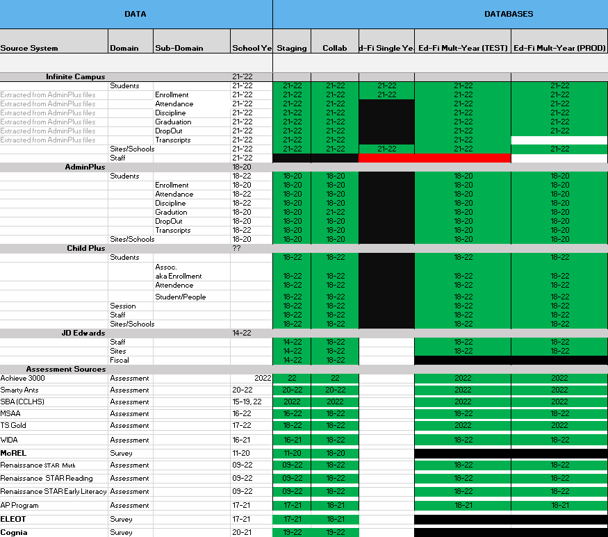

Figure 2: CNMI Data Source Ingestion and Mapping

DBDriven continues efforts to build, tune and configure the Development, Test and Production environments for the K12 SLDS, P20W and EWS. Figure 3 provides the state of the CNMI PSS hosting physical environment.

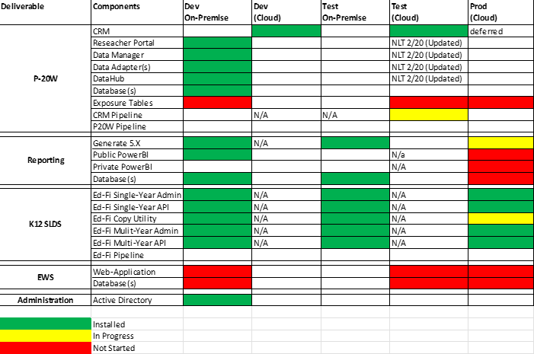

Figure 3: CNMI PSS SLDS & P20W Infrastructure Status

Figure 4 provides the state of the CNMI PSS data environments and components.

Figure 4: CNMI PSS SLDS & P20W Data Pipeline Status