DB Driven, LLC

100 Riverside Parkway

Fredericksburg, VA 22406

CNMI PSS Monthly Status report

1 – 29 February 2024

Table of Contents and Figures

Table of Contents and Figures 1

Monthly Status Report 2

Onboard P20W Data Sets as needed 2

Ongoing Support Services 2

1.1 System Maintenance and Performance Tuning 3

Figure 2: CNMI Data Source Ingestion and Mapping 3

Figure 3: CNMI PSS SLDS & P20W Infrastructure Status 4

Figure 4: CNMI PSS SLDS & P20W Data Pipeline Status 6

1.2 Project Management Events 7

1.3 Infrastructure Events 11

1.4 Development Events 13

1.5 Azure Dev Ops Events 14

## **Monthly Status Report**

This document provides the Monthly Status Report for the Period 1-29 February 2024. This monthly status report is Deliverable # 29 of the PSS Contract Number 165567 - OC.

## **Onboard P20W Data Sets as needed**

To date, all CNMI data sources have been ingested into the CNMI Multi-year data warehouse. DBDriven processes provide daily updates and ingestion of CNMI PSS data into the K12 SLDS.

## **Ongoing Support Services**

DBDriven performed the following support services during February 2024.

* Implemented Change Requests for the School Report Card.
* Updated Kindergarten Renaissance Data for the Academic Achievement report.
* Added a ‘Result as of: xx/xx/xxxx’ field to the PowerBI reports.
* Refreshed Assessment data in the Academic Achievement report and Admin Dashboard.
* Updated the Facts & Figures and Admin Dashboard with Principal data on the School Staff pages.
* Compiled a list of LEA ADM, LEA SUP, and SCH ADM users for Admin Dashboard access and shared with CNMI for validation.
* Addressed access issues for users of the PowerBI reports.
* Responded to trouble tickets for user accounts and access.
* Requested and loaded Fall term SBA data to the Prod EdFi warehouse.
* Synced Local Ethnicity data from IC to the Test EdFi warehouse.
* Created User accounts and a Research Purpose for CNMI training in the P-20W CRM environment.
* Continued testing of the Test Cloud P-20W solution CRM, Researcher Portal, Data Dictionary and Data Request Tool.
* Created the Student Attendance table for the P20W.
* Monitored synchronization of the 2023-24 Single Year.
* Provided environment and database access to Jeff Wheaton (AEM) to troubleshoot the Generate 11 issues.
* Participated in the Project Management call on 6 Feb (ChST).
* Participated in the Project Management call on 13 Feb (ChST).
* Participated in the Project Management call on 21 Feb (ChST).
* Participated in the Project Management call on 27 Feb (ChST).
* Participated in the Technical call on 1 Mar (ChST).

## **System Maintenance and Performance Tuning**

Figure 1 provides the status of CNMI PSS system data. Depending on the data source, data is ingested daily, monthly, quarterly, or annually.

During this period, DBDriven provided ongoing maintenance and tuning of each data source and the collective data repositories within each environment (Development, Test, Production).

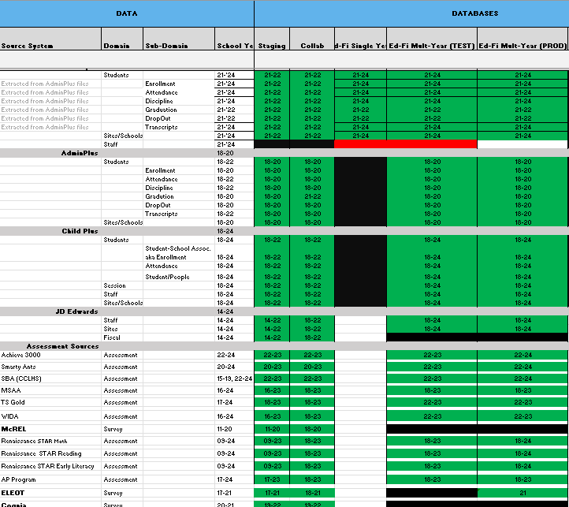

Figure 1: CNMI Data Source Ingestion and Mapping

DBDriven continues efforts to build, tune and configure the Development, Test and Production environments for the K12 SLDS, P20W and EWS.

Figure 2 provides the state of the CNMI PSS hosting physical environment.

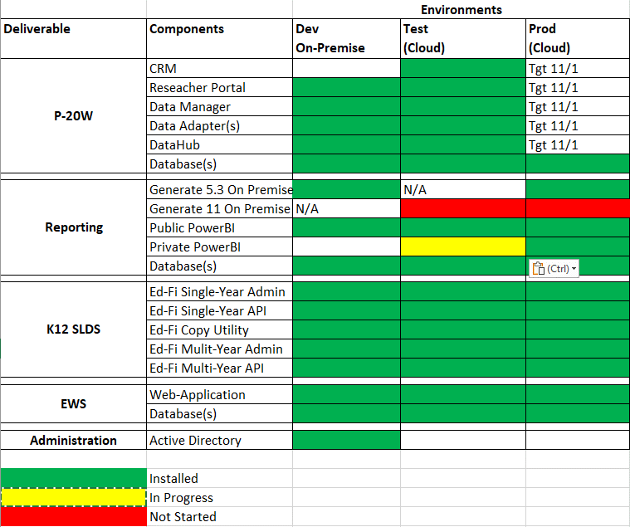

Figure 2: CNMI PSS SLDS & P20W Infrastructure Status

Figure 3 provides the Uptime Report for Infinite Campus Staging and Production environments, and for the Early Warning System.

Figure 3: Uptime Reports

Figure 4 provides the state of Generate 5.3 Test Results.

Figure 4: Generate 5.3 Test Results

Figure 5 provides the state of Generate 11.0 Test Results.

Figure 5: Generate 11.0 Test Results

Figure 6 provides the state of the CNMI PSS data environments and components.

Figure 6: CNMI PSS SLDS & P20W Data Pipeline Status

## **Project Management Events**

**Project Management Cont’d**

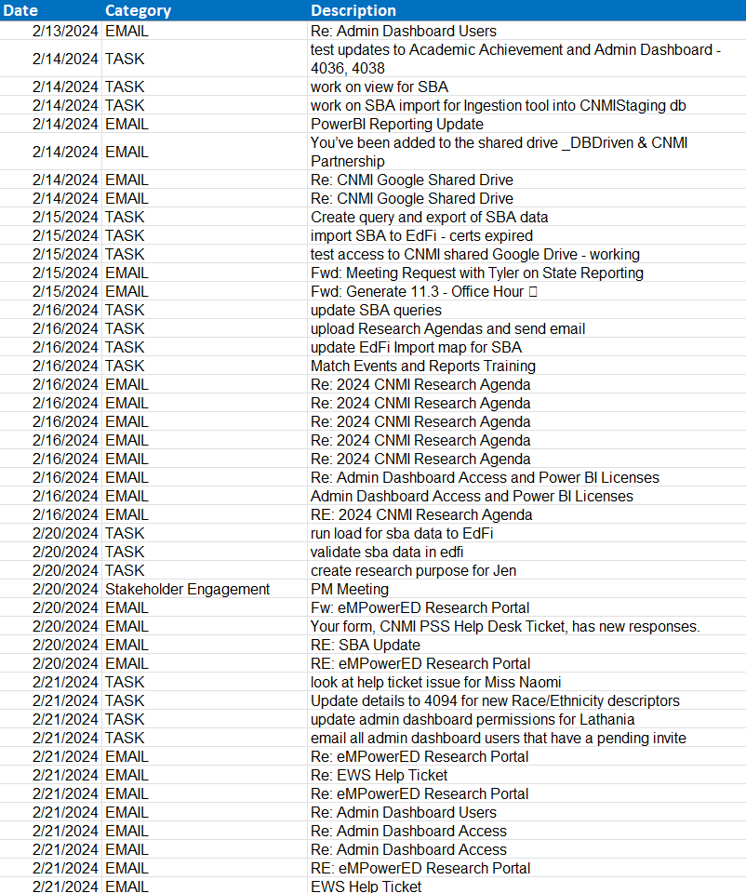

**Project Management Cont’d**

**Project Management Cont’d**

## **Infrastructure Events**

**Infrastructure Cont’d**

## **Development Events**

## **Azure Dev Ops Events**

