DB Driven, LLC

100 Riverside Parkway

Fredericksburg, VA 22406

CNMI PSS Monthly Status report

1 – 31 January 2023

Table of Contents and Figures

Table of Contents and Figures 1

Monthly Status Report 2

Onboard P20W Data Sets as needed 2

Figure 1: EdFi SqlData Dictionary 2

Ongoing Support Services 2

System Maintenance and Performance Tuning 3

Figure 2: CNMI Data Source Ingestion and Mapping 4

Figure 3: CNMI PSS SLDS & P20W Infrastructure Status 5

Figure 4: CNMI PSS SLDS & P20W Data Pipeline Status 6

## **Monthly Status Report**

This document provides the Monthly Status Report for the Period 1-31 January 2023. This monthly status report is Deliverable # 16 of the PSS Contract Number 165567 - OC.

## **Onboard P20W Data Sets as needed**

To date, all CNMI data sources have been ingested into the CNMI Multi-year data warehouse. DBDriven processes provide daily updates and ingestion of CNMI PSS data into the K12 SLDS.

DBDriven provided CNMI with a list of 2,493 possible K12 data elements to be exposed to the P20W solution on Jan 25, 2023. Figure 1 is a snapshot of the elements provided for CNMI review.

Figure 1: EdFi SqlData Dictionary

## **Ongoing Support Services**

DBDriven performed the following support services during January 2023.

* Installed and tested Generate 5.2. Successfully ran FS029 (Directory), FS039 (Grades), and FS052 (Membership).
* Met with CIID on Generate 5.2 testing to troubleshoot FS059 (Staff).
* Provided EWS Requirements documentation for CNMI review and feedback.
* Drafted and provided for review a Reporting Requirements Matrix.
* Continued development of the P20W CRM solution and created the Azure Test environment instance.
* Continued design and development for the Facts & Figures report.
* Received updated SBA (CCLHS) data.
* Received updated JDE data.
* Continued development and testing of the data ingestion solution (automated ingestion for Assessment data)
* Met with Tony Reyes and CNMI staff to review JD Edwards fiscal and staff data and reports on 4 Jan (ChST)
* Updated cloud configuration for Test and Production environments.
* Updated the draft Reports Requirements Matrix.
* Continued development of the P20W CRM solution.
* Ingested Cognia survey data into the Collab database.
* Continued ingestion activities for SmartyAnts, McREL and ELEOT data.
* Staged and initiated mapping for SBA (CCLHS) data.
* Met with Renaissance (Amanda Stampfli) to review data staging process
* Continued development and testing of the data ingestion solution (automated ingestion for Assessment data)
* Provided meeting minutes for the JD Edwards review meeting.
* Conducted Technical session on January 13 (ChST) to address Infinite Campus data and users.
* Participated in CNMI’s Status meeting with NCES and CIID on January 12 (ChST)
* Continued build-out of the Test and Production cloud environments (infrastructure).
* Conducted internal reviews of the Facts & Figures report.
* Completed ingestion for SmartyAnts data.
* Initiated ingestion of 2022 SBA (CCLHS) data.
* Conducted Technical session on January 18 (ChST)
* Conducted EWS requirements review on January 19 and 20 (ChST)
* Provided a preview of the Facts & Figures report to CNMI on Jan 26 (ChST).
* Completed ingestion of TS Gold.
* Completed ingestion of JD Edwards fiscal data into the Collab database.
* Finalized development and testing of the data ingestion solution (automated ingestion for Assessment data) in the Test environment.
* Conducted Technical session on January 25 (ChST)
* Provided technical support for choosing whether to use record level or aggregate level data for public reports.
* Began receiving staff data from Infinite Campus through EdFi
* Received IEP and ELL program membership data from Infinite Campus through EdFi
* Received additional accounts and permissions for Will Goldschmidt, Tamra Arant and Kurt Fisher

## **System Maintenance and Performance Tuning**

Figure 2 provides the status of CNMI PSS system data. Depending on the data source, data is ingested daily, monthly, quarterly, or annually. During this period, DBDriven provided ongoing maintenance and tuning of each data source and the collective data repositories within each environment (Development, Test, Production).

Figure 2: CNMI Data Source Ingestion and Mapping

DBDriven continues efforts to build, tune and configure the Development, Test and Production environments for the K12 SLDS, P20W and EWS. Figure 3 provides the state of the CNMI PSS hosting physical environment.

Figure 3: CNMI PSS SLDS & P20W Infrastructure Status

Figure 4 provides the state of the CNMI PSS data environments and components.

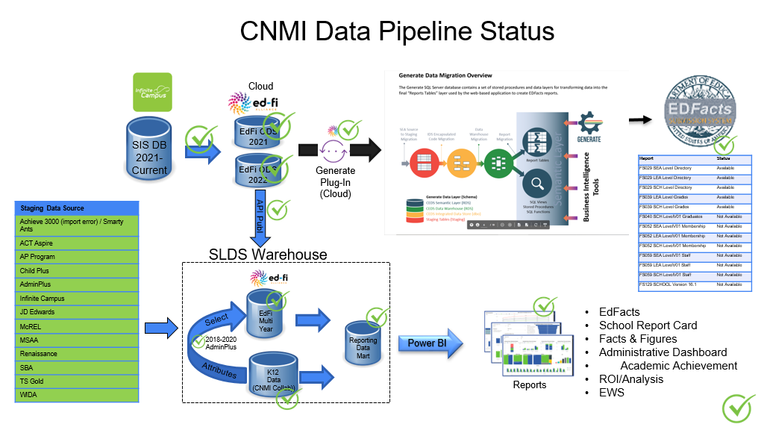

Figure 4: CNMI PSS SLDS & P20W Data Pipeline Status