DB Driven, LLC

100 Riverside Parkway

Fredericksburg, VA 22406

CNMI PSS Monthly Status report

1 – 31 January 2024

Table of Contents and Figures

Table of Contents and Figures 1

Monthly Status Report 2

Onboard P20W Data Sets as needed 2

Ongoing Support Services 2

1.1 System Maintenance and Performance Tuning 3

Figure 2: CNMI Data Source Ingestion and Mapping 3

Figure 3: CNMI PSS SLDS & P20W Infrastructure Status 4

Figure 4: CNMI PSS SLDS & P20W Data Pipeline Status 6

1.2 Project Management Events 7

1.3 Infrastructure Events 9

1.4 Development Events 10

1.5 Azure Dev Ops Events 11

## **Monthly Status Report**

This document provides the Monthly Status Report for the Period 1-31 January 2024. This monthly status report is Deliverable # 28 of the PSS Contract Number 165567 - OC.

## **Onboard P20W Data Sets as needed**

To date, all CNMI data sources have been ingested into the CNMI Multi-year data warehouse. DBDriven processes provide daily updates and ingestion of CNMI PSS data into the K12 SLDS.

## **Ongoing Support Services**

DBDriven performed the following support services during January 2024.

* Corrected the issue with select students who are appearing in the EWS at their old school, as well as their new school.
* Met with CIID and CNMI regarding the Generate software application and its use going forward.
* Provided student data for completing the FS175, FS178, FS185 and FS188 EdFacts reports.
* Provided one-time cost estimates to CNMI for development of the EdFacts CSV submission files.
* Addressed access issues for users of the Administration Dashboard.
* Responded to trouble tickets for user accounts and access.
* Populated the Early Learning web application with the current roster provided by CNMI.
* Completed testing the P-20W solution CRM, Researcher Portal, Data Dictionary and Data Request Tool.
* Created the Student Demographics, Smarty Ants, Achieve 3000, and the Renaissance STAR Early Literacy, Math and Reading assessment tables for the P20W.
* Monitored synchronization of the 2023-24 Single Year.
* Participated in the Project Management and Technical calls on 2 Jan (ChST).
* Participated in the Project Management and Technical calls on 9 Jan (ChST).
* Participated in the Technical call on 16 Jan (ChST).
* Participated in the Technical call on 23 Jan (ChST).
* Participated in the Technical call on 30Jan (ChST).

## **System Maintenance and Performance Tuning**

Figure 1 provides the status of CNMI PSS system data. Depending on the data source, data is ingested daily, monthly, quarterly, or annually.

During this period, DBDriven provided ongoing maintenance and tuning of each data source and the collective data repositories within each environment (Development, Test, Production).

Figure 1: CNMI Data Source Ingestion and Mapping

DBDriven continues efforts to build, tune and configure the Development, Test and Production environments for the K12 SLDS, P20W and EWS.

Figure 2 provides the state of the CNMI PSS hosting physical environment.

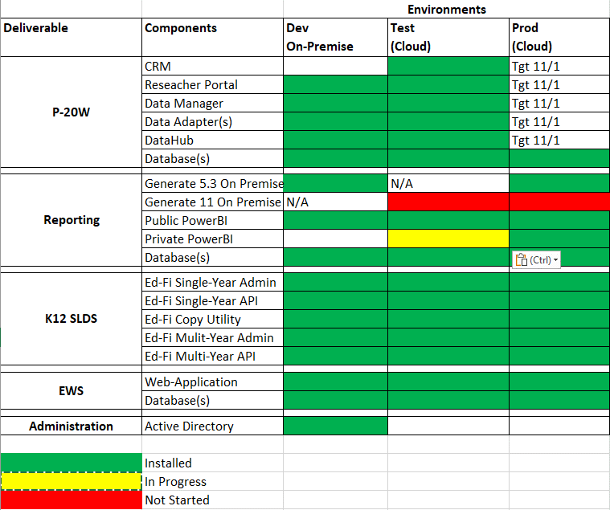

Figure 2: CNMI PSS SLDS & P20W Infrastructure Status

Figure 3 provides the state of Generate 5.3 Test Results.

Figure 3: Generate 5.3 Test Results

Figure 4 provides the state of Generate 11.0 Test Results.

Figure 4: Generate 11.0 Test Results

Figure 5 provides the state of the CNMI PSS data environments and components.

Figure 5: CNMI PSS SLDS & P20W Data Pipeline Status

## **Project Management Events**

Project Management Cont’d

## **Infrastructure Events**

## **Development Events**

## **Azure Dev Ops Events**

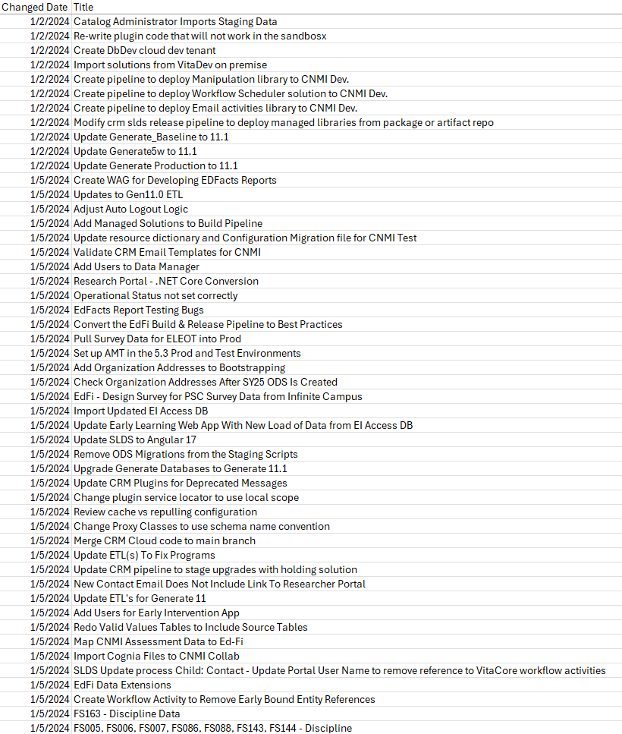

Azure Dev Ops Events Cont’d

Azure Dev Ops Events Cont’d

