DB Driven, LLC

100 Riverside Parkway

Fredericksburg, VA 22406

CNMI PSS Monthly Status report

1 – 31 July 2023

Table of Contents and Figures

Table of Contents and Figures 1

Monthly Status Report 2

Onboard P20W Data Sets as needed 2

Ongoing Support Services 2

1.1 System Maintenance and Performance Tuning 4

Figure 2: CNMI Data Source Ingestion and Mapping 4

Figure 3: CNMI PSS SLDS & P20W Infrastructure Status 5

Figure 4: CNMI PSS SLDS & P20W Data Pipeline Status 6

1.2 Project Management Events 7

1.3 Infrastructure Events 12

1.4 Development Events 13

1.5 Azure Dev Ops Events 14

## **Monthly Status Report**

This document provides the Monthly Status Report for the Period 1-31 July 2023. This monthly status report is Deliverable # 22 of the PSS Contract Number 165567 - OC.

## **Onboard P20W Data Sets as needed**

To date, all CNMI data sources have been ingested into the CNMI Multi-year data warehouse. DBDriven processes provide daily updates and ingestion of CNMI PSS data into the K12 SLDS.

## **Ongoing Support Services**

DBDriven performed the following support services during July 2023.

* Continued build-out of the Test and Production cloud environments (infrastructure).
  + Continued configuration of the P20W CRM solution (development).
* Continued development on the P-20W solution.
* Continued work on the EWS solution.
* Began System Integration Testing of the EWS Solution.
* Completed work on the EWS solution, to include incorporating functionality for the Teachers to create an Intervention Plan.
* Completed System Integration Testing (SIT) of the EWS.
* Created Test accounts for EWS UAT participants.
* Emailed instructions and test scripts to the EWS UAT participants.
* Responded to EWS UAT Questions and access issues.
* Coordinated updates for the Academic Achievement Report for CNMI .
* Monitored synchronization of the 2023 Single Year.
* Monitored 2024 Single Year instance.
* Continued analysis of the FS002 report.
* Completed analysis of the FS002 report. Missing records are due to the Infinite Campus configuration for Special Needs participants.
* Published updates to the Academic Achievement Report.
* Met internally to DBDriven to review the Administrative Dashboard requirements.
* Received 2022 AP Program Data.
* Analyzed the 2022 AP Program data and identified 166 records with missing IDs. Conducted a deterministic match (name and DOB) and reconciled missing IDs.
* Imported SY2022 AP data to EdFi Multiyear warehouse.
* Received 2023 WIDA data.
* Analyzed the 2023 WIDA data and identified 119 “unmatched” students. Requested CNMI provide additional student data.
* Imported SY2023 WIDA data to EdFi Multiyear warehouse.
* Participated in the Project Update call on 6 July (ChST).
* Participated in the Project Management and Technical calls on 11 July (ChST).
* Participated in the Project Management and Technical calls on 18 July (ChST).
* Participated in the Project Update call on 20 July (ChST).
* Participated in the Project Management and Technical calls on 1 Aug (ChST).
* DW Mapping, Extraction and Transformation (ongoing).

## **System Maintenance and Performance Tuning**

Figure 2 provides the status of CNMI PSS system data. Depending on the data source, data is ingested daily, monthly, quarterly, or annually.

During this period, DBDriven provided ongoing maintenance and tuning of each data source and the collective data repositories within each environment (Development, Test, Production).

Figure 2: CNMI Data Source Ingestion and Mapping

DBDriven continues efforts to build, tune and configure the Development, Test and Production environments for the K12 SLDS, P20W and EWS.

Figure 3 provides the state of the CNMI PSS hosting physical environment.

Figure 3: CNMI PSS SLDS & P20W Infrastructure Status

Figure 4 provides the state of Generate Test Results.

Figure 5 provides the state of the CNMI PSS data environments and components.

Figure 4: CNMI PSS SLDS & P20W Data Pipeline Status

## **Project Management Events**

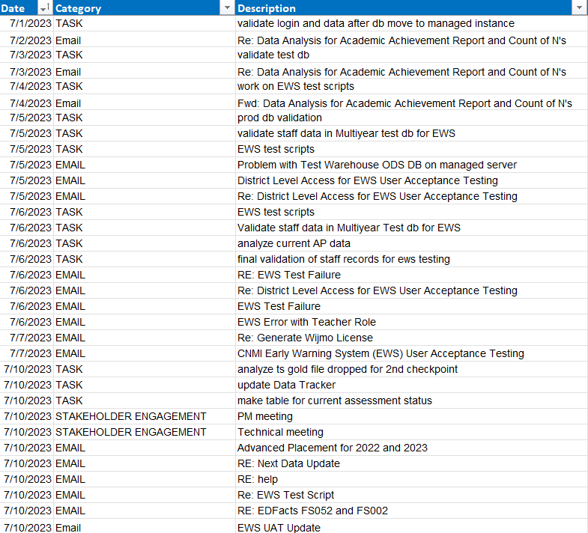

Project Management Cont’d

Project Management Cont’d

Project Management Cont’d

Project Management Cont’d

## **Infrastructure Events**

## **Development Events**

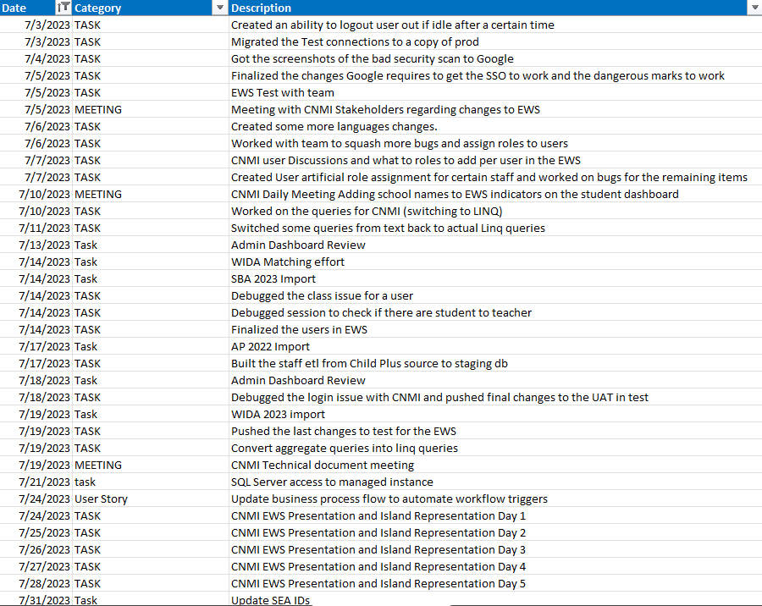

## **Azure Dev Ops Events**

