DB Driven, LLC

100 Riverside Parkway

Fredericksburg, VA 22406

CNMI PSS Monthly Status report

1 – 30 June 2023

Table of Contents and Figures

Table of Contents and Figures 1

Monthly Status Report 2

Onboard P20W Data Sets as needed 2

Ongoing Support Services 2

System Maintenance and Performance Tuning 3

Figure 2: CNMI Data Source Ingestion and Mapping 3

Figure 3: CNMI PSS SLDS & P20W Infrastructure Status 4

Figure 4: CNMI PSS SLDS & P20W Data Pipeline Status 5

1.1 Project Management Events 6

1.2 Infrastructure Events 9

1.3 Development Events 10

1.4 Azure Dev Ops Events 11

## **Monthly Status Report**

This document provides the Monthly Status Report for the Period 1-30 June 2023. This monthly status report is Deliverable # 21 of the PSS Contract Number 165567 - OC.

## **Onboard P20W Data Sets as needed**

To date, all CNMI data sources have been ingested into the CNMI Multi-year data warehouse. DBDriven processes provide daily updates and ingestion of CNMI PSS data into the K12 SLDS.

## **Ongoing Support Services**

DBDriven performed the following support services during June 2023.

* Continued build-out of the Test and Production cloud environments (infrastructure).
  + Continued configuration of the P20W CRM solution (development).
* Continued development on the P-20W solution
* Completed development and testing to ingest of ChildPlus into the Generate reports
* Republished the Generate Application with the FS002, 029, 039, 033 and 052 reports.
* Continued analysis of the FS002 report.
* Continued development of the Academic Achievement Report
* Coordinated updates for the Academic Achievement Report for CNMI
* Posted an updated Academic Achievement Report for CNMI review
* Provided data elements for Smarty Ants, ChildPlus and Admin Plus
* Provided the Data Collection Calendar
* Provided feedback for the Data Source Agreement for Infinite Campus
* Continued work on the EWS solution
* Began System Integration Testing of the EWS Solution
* Monitored synchronization of the 2023 Single Year
* Monitored 2024 Single Year instance.
* Participated in the Project Management and Technical calls on 6 Jun (ChST)
* Participated in the Project Update call on 8 Jun (ChST)
* Participated in the Project Management and Technical calls on 13 Jun (ChST)
* Participated in the Project Management and Technical calls on 20 Jun (ChST)
* Participated in EWS demonstration meeting 21 and 22 Jun (ChST).
* Participated in the Project Update call on 22 Jun (ChST)
* Participated in the Project Management and Technical calls on 27 Jun (ChST)
* Participated in CIID Early Childhood and SLDS Grant meetings with CNMI.
* DW Mapping, Extraction and Transformation (ongoing)

## **System Maintenance and Performance Tuning**

Figure 2 provides the status of CNMI PSS system data. Depending on the data source, data is ingested daily, monthly, quarterly, or annually. During this period, DBDriven provided ongoing maintenance and tuning of each data source and the collective data repositories within each environment (Development, Test, Production).

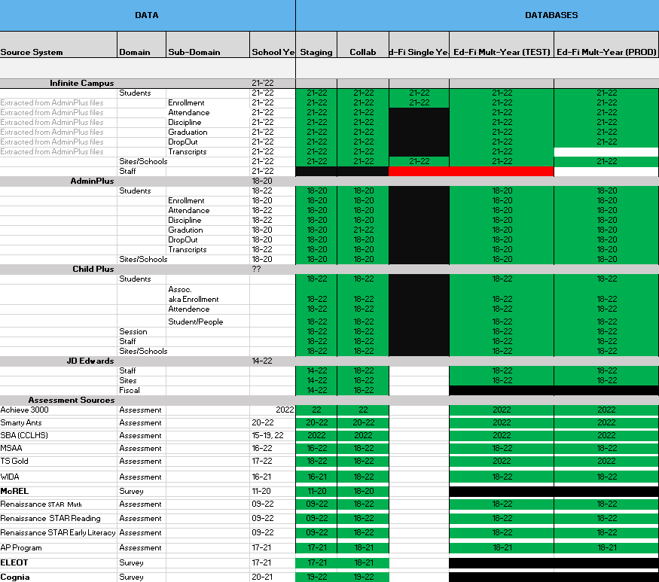

Figure 2: CNMI Data Source Ingestion and Mapping

DBDriven continues efforts to build, tune and configure the Development, Test and Production environments for the K12 SLDS, P20W and EWS.

Figure 3 provides the state of the CNMI PSS hosting physical environment.

Figure 3: CNMI PSS SLDS & P20W Infrastructure Status

Figure 4 provides the state of Generate Test Results.

Figure 5 provides the state of the CNMI PSS data environments and components.

Figure 4: CNMI PSS SLDS & P20W Data Pipeline Status

## **Project Management Events**

Project Management Cont’d

Project Management Cont’d

## **Infrastructure Events**

## **Development Events**

## **Azure Dev Ops Events**

