DB Driven, LLC

100 Riverside Parkway

Fredericksburg, VA 22406

CNMI PSS Monthly Status report

1 – 31 March 2023

Table of Contents and Figures

Table of Contents and Figures 1

Monthly Status Report 2

Onboard P20W Data Sets as needed 2

Ongoing Support Services 2

System Maintenance and Performance Tuning 3

Figure 2: CNMI Data Source Ingestion and Mapping 4

Figure 3: CNMI PSS SLDS & P20W Infrastructure Status 5

Figure 4: CNMI PSS SLDS & P20W Data Pipeline Status 6

1.1 Project Management 7

1.2 Infrastructure 10

1.3 Development 11

1.4 TFS 12

## **Monthly Status Report**

This document provides the Monthly Status Report for the Period 1-31 March 2023. This monthly status report is Deliverable # 18 of the PSS Contract Number 165567 - OC.

## **Onboard P20W Data Sets as needed**

To date, all CNMI data sources have been ingested into the CNMI Multi-year data warehouse. DBDriven processes provide daily updates and ingestion of CNMI PSS data into the K12 SLDS.

## **Ongoing Support Services**

DBDriven performed the following support services during March 2023.

* Updated the School Report Card to use 2022 attendance data provided by CNMI.
* Identified irregularities with the SY 2023 attendance data, which impacts the School Report Card, and communicated these with CNMI.
* Updated and republished the School Report Card.
* Internally reviewed Academic Achievement reporting requirements prior to development.
* Initiated and Continued validation of data for use with the Academic Achievement report.
* Initiated and Continued development of the Academic Achievement Report, including creation of staging tables.
* Provided a URL to CNMI for review and feedback of the Facts and Figures report.
* Received and reviewed the Draft SY2022 – 2023 Facts & Figures. Compared student counts within the draft report to data warehouse. Differences are minor and within the statistical variations in most cases.
* Met with AEM to review Generate 5.3 configuration and issues. Continued testing for C029, C039, C052 and C059. DBDriven was able to produce the reports with Ver 5.3.
* Continued testing the 27 EdFacts reports in Generate 5.3 with AEM data.
* Continued testing the C029, C039, C052 and C059 in Generate 5w with CNMI data.
* Training of Generate EdFacts reports on March 29th to CNMI representatives.
* Completed testing Single Sign On (SSO) for the EWS using Google and conducting data validation for indicators.
* Continued development of the landing pages for the EWS.
* Demonstrated the EWS mock-ups to and collected feedback from CNMI.
* Installed the P20W data components in the Test Environment, to include the Data Manager, Data Hub and Data Adapter.
* Continued build-out of the Test and Production cloud environments (infrastructure).
  + Successfully installed and configured the API copy utility for incremental updates of the Ed-Fi single year and multi-year databases in ‘Test’.
  + Continued configuration of the P20W CRM solution (development).
  + Finalized design for the CRM dialogues.
  + Pushed and tested the design for the CRM dialogues to ‘Test’.
  + Continued development of the workflow queuing, which affects amendments, catalogs, and research purposes.
  + Continued development work on the CRM proxy services.
  + Began Dev testing of the P20W data components in the Test Environment, to include the Data Manager, Data Hub and Data Adapter.
* Continued work to install the Copy API into Production for 2023.
* Continued coordination with CIID to troubleshoot use of Active Directory with Generate in the Azure cloud environment.
* Continued work on automating the synchronization of 2023 Child+ data into Test and Production.
* Developed hierarchical structure for Job Types to support reporting.
* Provided DBDriven’s response to Data Management practices questions for CNMI’s Data Governance Manual.
* Updated Smarty Ants, Achieve 3000 and WIDA warehouse data.
* Conducted PM status meeting with CNMI representatives 7 Mar ChST.
* Conducted PM status meeting with CNMI representatives 14 Mar ChST.
* Conducted PM status meeting with CNMI representatives 21 Mar ChST.
* Conducted PM status meeting with CNMI representatives 28 Mar ChST.

## **System Maintenance and Performance Tuning**

Figure 2 provides the status of CNMI PSS system data. Depending on the data source, data is ingested daily, monthly, quarterly, or annually. During this period, DBDriven provided ongoing maintenance and tuning of each data source and the collective data repositories within each environment (Development, Test, Production).

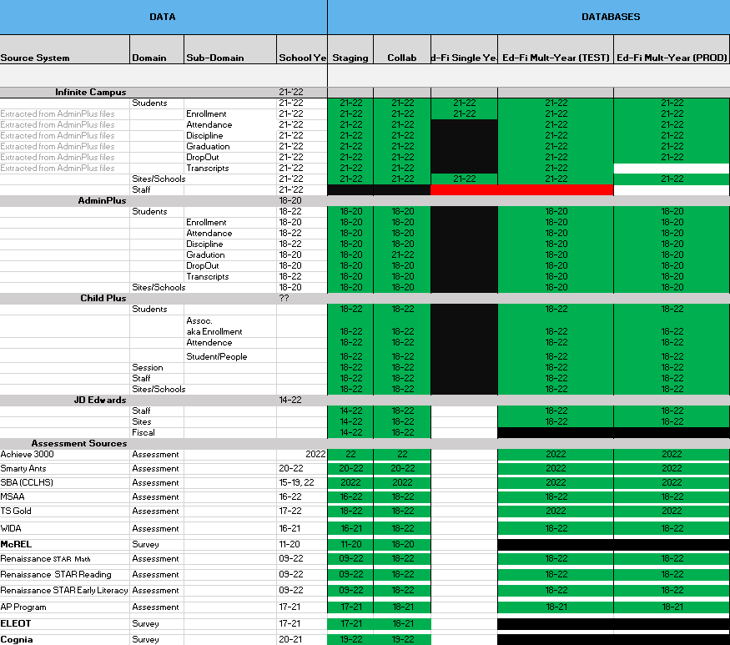

Figure 2: CNMI Data Source Ingestion and Mapping

DBDriven continues efforts to build, tune and configure the Development, Test and Production environments for the K12 SLDS, P20W and EWS.

Figure 3 provides the state of the CNMI PSS hosting physical environment.

Figure 3: CNMI PSS SLDS & P20W Infrastructure Status

Figure 4 provides the state of the CNMI PSS data environments and components.

Figure 4: CNMI PSS SLDS & P20W Data Pipeline Status

## **Project Management Events**

## **Infrastructure Events**

## **Development Events**

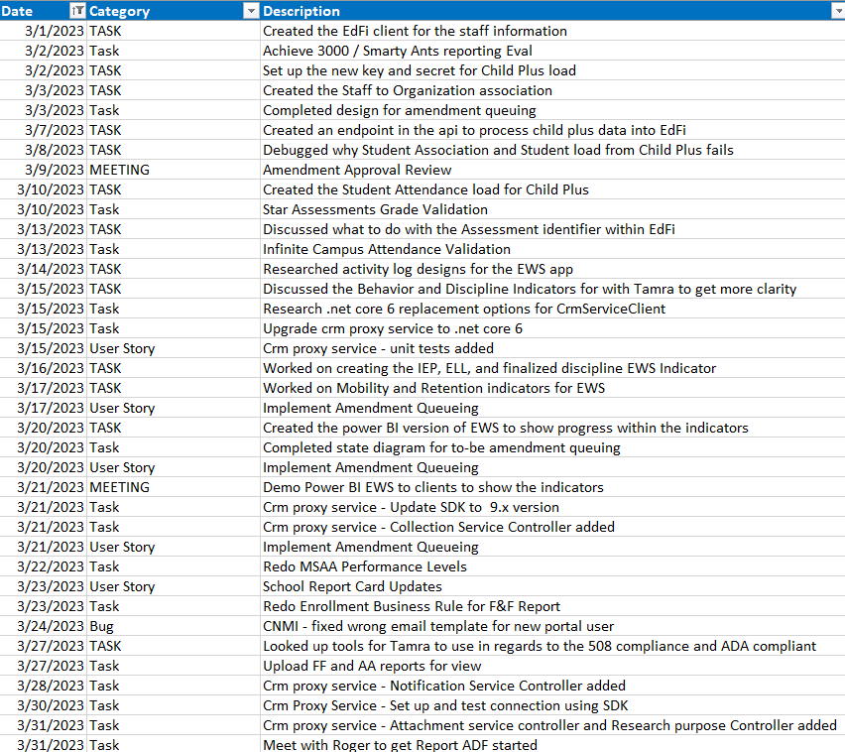

## **Azure Dev Ops Events**

ADO Cont’d

