DB Driven, LLC

100 Riverside Parkway

Fredericksburg, VA 22406

CNMI PSS Monthly Status report

1 – 31 May 2023

Table of Contents and Figures

Table of Contents and Figures 1

Monthly Status Report 2

Onboard P20W Data Sets as needed 2

Ongoing Support Services 2

System Maintenance and Performance Tuning 4

Figure 2: CNMI Data Source Ingestion and Mapping 4

Figure 3: CNMI PSS SLDS & P20W Infrastructure Status 5

Figure 4: CNMI PSS SLDS & P20W Data Pipeline Status 6

1.1 Project Management Events 7

1.2 Infrastructure Events 13

1.3 Development Events 15

1.4 Azure Dev Ops Events 16

## **Monthly Status Report**

This document provides the Monthly Status Report for the Period 1-31 May 2023. This monthly status report is Deliverable # 20 of the PSS Contract Number 165567 - OC.

## **Onboard P20W Data Sets as needed**

To date, all CNMI data sources have been ingested into the CNMI Multi-year data warehouse. DBDriven processes provide daily updates and ingestion of CNMI PSS data into the K12 SLDS.

## **Ongoing Support Services**

DBDriven performed the following support services during May 2023.

* Continued build-out of the Test and Production cloud environments (infrastructure).
  + Continued configuration of the P20W CRM solution (development). Completed development work on the CRM proxy services.
  + Continued development and testing of the P20W data components in the Test Environment, to include the Data Manager, Data Hub and Data Adapter.
* Continued testing the 27 EdFacts reports in Generate 5.3.
* Completed testing EdFacts reports (due in June) in Generate 5.3. See Image 4 below for Generate Test Status.
* Issued credentials for CNMI personnel to review EdFacts reports.
* Continued development for automating the synchronization of 2023 ChildPlus data into Production.
* Tested ingestion of ChildPlus into the Generate reports in Dev.
* Continued work on the EWS solution.
* Requested updated 2023 assessment data for SBA, WIDA, MSAA, and TS Gold.
* Continued development of the School Report Card.
* Continued development of the Academic Achievement Report.
* Monitored synchronization of the 2023 Single Year.
* Established Ed-Fi 2024 Single Year instance.
* Monitored 2024 Single Year instance.
* Demonstrated the EWS to CNMI on 5/12 ChST.
* Participated in CIID Early Childhood and SLDS Grant meetings with CNMI.
* Conducted PM status meeting and Technical meeting with CNMI representatives 2 May ChST.
* Conducted PM status meeting and Technical meeting with CNMI representatives 9 May ChST.
* Conducted PM status meeting and Technical meeting with CNMI representatives 16 May ChST.
* Conducted Data Suppression meeting with CNMI representatives 18 May ChST.
* Conducted Project Updates/PM status meeting with CNMI representatives 25 May ChST.
* Conducted PM status meeting and Technical meeting with CNMI representatives 30 May ChST.

## **System Maintenance and Performance Tuning**

Figure 2 provides the status of CNMI PSS system data. Depending on the data source, data is ingested daily, monthly, quarterly, or annually. During this period, DBDriven provided ongoing maintenance and tuning of each data source and the collective data repositories within each environment (Development, Test, Production).

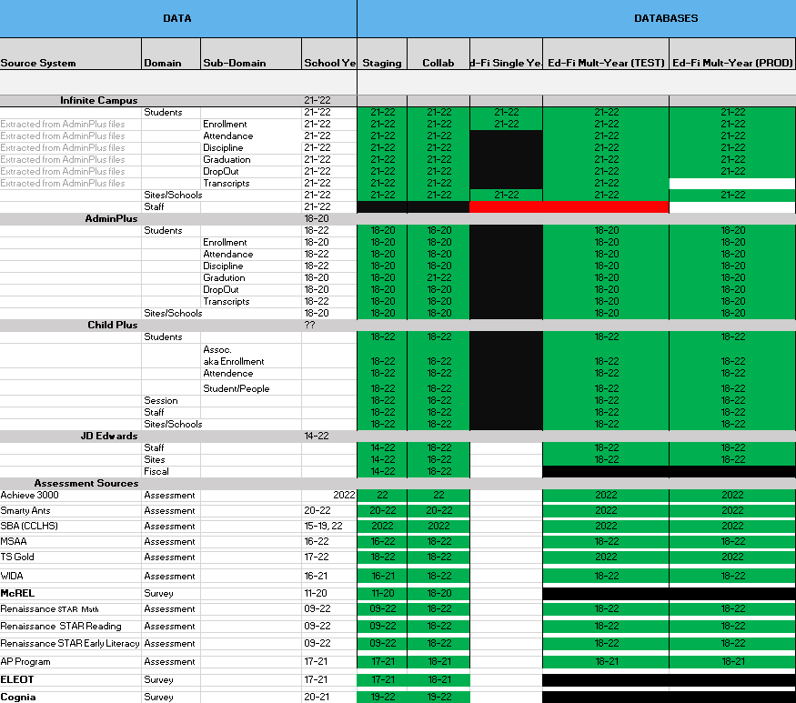

Figure 2: CNMI Data Source Ingestion and Mapping

DBDriven continues efforts to build, tune and configure the Development, Test and Production environments for the K12 SLDS, P20W and EWS.

Figure 3 provides the state of the CNMI PSS hosting physical environment.

Figure 3: CNMI PSS SLDS & P20W Infrastructure Status

Figure 4 provides the state of Generate Test Results.

Figure 5 provides the state of the CNMI PSS data environments and components.

Figure 4: CNMI PSS SLDS & P20W Data Pipeline Status

## **Project Management Events**

Project Management Cont’d

Project Management Cont’d

Project Management Cont’d

Project Management Cont’d

Project Management Cont’d

## **Infrastructure Events**

Infrastructure Cont’d

## **Development Events**

## **Azure Dev Ops Events**

ADO Cont’d

ADO Cont’d

