DB Driven, LLC

100 Riverside Parkway

Fredericksburg, VA 22406

CNMI PSS Monthly Status report

1 – 30 November 2023

Table of Contents and Figures

Table of Contents and Figures 1

Monthly Status Report 2

Onboard P20W Data Sets as needed 2

Ongoing Support Services 2

1.1 System Maintenance and Performance Tuning 3

Figure 2: CNMI Data Source Ingestion and Mapping 3

Figure 3: CNMI PSS SLDS & P20W Infrastructure Status 4

Figure 4: CNMI PSS SLDS & P20W Data Pipeline Status 6

1.2 Project Management Events 7

1.3 Infrastructure Events 10

1.4 Development Events 11

1.5 Azure Dev Ops Events 12

## **Monthly Status Report**

This document provides the Monthly Status Report for the Period 1-30 November 2023. This monthly status report is Deliverable # 26 of the PSS Contract Number 165567 - OC.

## **Onboard P20W Data Sets as needed**

To date, all CNMI data sources have been ingested into the CNMI Multi-year data warehouse. DBDriven processes provide daily updates and ingestion of CNMI PSS data into the K12 SLDS.

## **Ongoing Support Services**

DBDriven performed the following support services during November 2023.

* Continued and completed development on the EWS Middle and High School indicators.
* Tested the EWS Middle and High School indicators.
* Demonstrated the Middel and High School indicators to CNMIPSS..
* Deployed the EWS Middle and High School indicators to the Test environment.
* Provided updated requirements documentation for the EWS.
* Developed the EWS User Acceptance Test documentation.
* Monitored the EWS.
* Added ChildPlus ID lookup functionality to the Early Learning web application.
* Confirmed the Early Learning URL <https://earlylearning.cnmipss.org>.
* Provided test scripts and the URL to the CNMI Early Learning web application for UAT users.
* Requested class sizes for 2018-2019, 2019-2020 and 2021-2022 in order to calculate the graduation rates based on Average Cohort Graduation Rate (ACGR).
* Finalized and released the School Report Card for CNMI review.
* Continued testing the P-20W solution CRM, Researcher Portal, Data Dictionary and Data Request Tool.
* Provided sample banners with different acronyms for the my eMPowerED Researcher Portal.
* Published the Google Forms Trouble Ticket intake form.
* Developed, deployed and tested Generate 11 Staging Table scripts.
* Met with AEM on multiple occasions to troubleshoot Generate 11.
* Monitored synchronization of the 2023-24 Single Year.
* Submitted the October Monthly O&M invoice and approval documents.
* Participated in the Project Management and Technical calls on 7 Nov (ChST).
* Participated in the Project Management and Technical calls on 14 Nov (ChST).
* Participated in the Project Management and Technical calls on 21 Nov (ChST).
* Participated in the Project Management and Technical calls on 28 Nov (ChST).

## **System Maintenance and Performance Tuning**

Figure 1 provides the status of CNMI PSS system data. Depending on the data source, data is ingested daily, monthly, quarterly, or annually.

During this period, DBDriven provided ongoing maintenance and tuning of each data source and the collective data repositories within each environment (Development, Test, Production).

Figure 1: CNMI Data Source Ingestion and Mapping

DBDriven continues efforts to build, tune and configure the Development, Test and Production environments for the K12 SLDS, P20W and EWS.

Figure 2 provides the state of the CNMI PSS hosting physical environment.

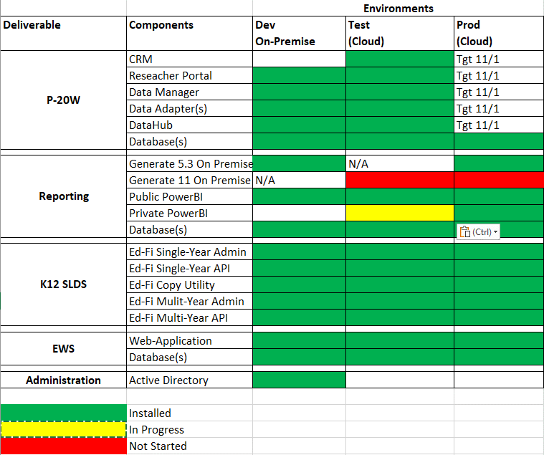

Figure 2: CNMI PSS SLDS & P20W Infrastructure Status

Figure 3 provides the state of Generate 5.3 Test Results.

Figure 3: Generate 5.3 Test Results

Figure 4 provides the state of Generate 11.0 Test Results.

Figure 4: Generate 11.0 Test Results

Figure 5 provides the state of the CNMI PSS data environments and components.

Figure 5: CNMI PSS SLDS & P20W Data Pipeline Status

## **Project Management Events**

Project Management Cont’d

Project Management Cont’d

## **Infrastructure Events**

## **Development Events**

## **Azure Dev Ops Events**

AZURE DEV OPS Cont’d

