DB Driven, LLC

100 Riverside Parkway

Fredericksburg, VA 22406

CNMI PSS Monthly Status report

1 – 30 September 2023

Table of Contents and Figures

Table of Contents and Figures 1

Monthly Status Report 2

Onboard P20W Data Sets as needed 2

Ongoing Support Services 2

1.1 System Maintenance and Performance Tuning 4

Figure 2: CNMI Data Source Ingestion and Mapping 4

Figure 3: CNMI PSS SLDS & P20W Infrastructure Status 5

Figure 4: CNMI PSS SLDS & P20W Data Pipeline Status 6

1.2 Project Management Events 7

1.3 Infrastructure Events 12

1.4 Development Events 13

1.5 Azure Dev Ops Events 14

## **Monthly Status Report**

This document provides the Monthly Status Report for the Period 1-30 September 2023. This monthly status report is Deliverable # 23 of the PSS Contract Number 165567 - OC.

## **Onboard P20W Data Sets as needed**

To date, all CNMI data sources have been ingested into the CNMI Multi-year data warehouse. DBDriven processes provide daily updates and ingestion of CNMI PSS data into the K12 SLDS.

## **Ongoing Support Services**

DBDriven performed the following support services during September 2023.

* Received CNMI input on School Report Card, Academic Achievement and Facts & Figures.
* Began updating and continued testing of the School Report Card, Academic Achievement and Facts and Figures reports.
  + Demonstrated the School Report Card to the PSS Accountability Taskforce.
* Completed updates to the School Report Card.
* Completed updates to the Academic Achievement Report.
* Conducted internal testing of the School Report Card, Academic Achievement and Facts and Figures reports.
* Continued internal testing and updates of the School Report Card, Academic Achievement and Facts and Figures reports.
* Provided screenshots of the Virginia P20W public portal.
* Provided SY 2022-23 Attendance rates for CNMI approval or modification.
* Provided screenshots of the Public Reports (School Report Card, Academic Achievement and Facts and Figures).
* Provided CNMI with Power BI credentials for viewing public reports.
* Initiated review of the Jan and Feb EdFacts Reports.
* Continued review of the Jan and Feb EdFacts Reporting requirements.
  + Awaiting response from CNMI on whether they intend to submit the reports. Currently, these reports are not working in the Generate tool.
* Troubleshooting and coordination with CNMI and CIID with the FS052 (Membership) report.
* Continued coordination with AEM regarding issues with the FS052 (Membership) report.
* Installed Generate 11 in the Test Environment.
* Continued build-out of the Test and Production cloud environments (infrastructure).
  + Continued configuration of the P20W CRM solution (development).
* Continued development on the P-20W solution.
* Establishment of the live connection to the ChildPlus Amazon Web Services (AWS) production and test databases.
* Pushed the Data Ingestion Tool to Production and completed the ingestion of ChildPlus 2023-24 data.
* Monitored the EWS Production environment.
* Monitored and provided help desk support for the EWS.
* Responded to questions/problems with logging into the EWS solution.
  + Issues related to setting the user’s email to ‘Private’, not having an ‘Assignment Code’ or having an incorrect ‘Assignment Code’, and not having a ‘Schedule’.
* Developed and provided a checklist of required EWS user configurations for use by CNMI to initially troubleshoot user login issues.
* Delivered the EWS user manual.
* Conducted Early Learning web application requirements and design review with CNMI.
* Began development of the Early Learning web application.
* Continued development of the Early Learning web application.
* Received SY23-24 EL roster from CNMI.
  + Note the EL Access Database contains far more information than the EL spreadsheet. This additional information is out of scope to the EL Web Application project.
* Monitored synchronization of the 2023-24 Single Year.
* Contacted Dave Gau (ShaveFX) for a price quote on the P20W About and Security videos.
* Submitted the August Monthly O&M invoice and approval documents.

## **System Maintenance and Performance Tuning**

Figure 2 provides the status of CNMI PSS system data. Depending on the data source, data is ingested daily, monthly, quarterly, or annually.

During this period, DBDriven provided ongoing maintenance and tuning of each data source and the collective data repositories within each environment (Development, Test, Production).

Figure 2: CNMI Data Source Ingestion and Mapping

DBDriven continues efforts to build, tune and configure the Development, Test and Production environments for the K12 SLDS, P20W and EWS.

Figure 3 provides the state of the CNMI PSS hosting physical environment.

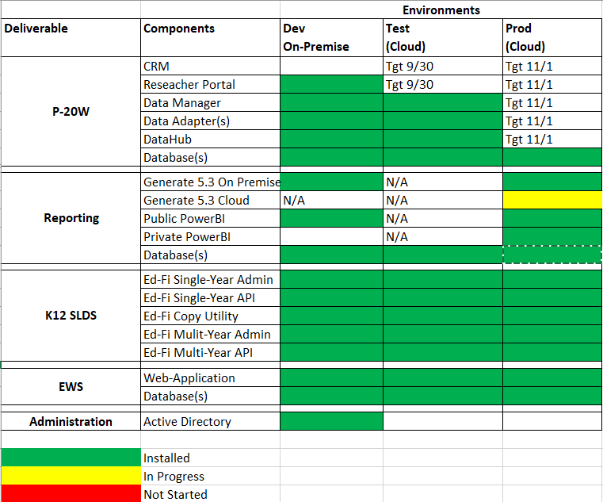

Figure 3: CNMI PSS SLDS & P20W Infrastructure Status

Figure 4 provides the state of Generate Test Results.

Figure 4: Generate Test Results

Figure 5 provides the state of the CNMI PSS data environments and components.

Figure 5: CNMI PSS SLDS & P20W Data Pipeline Status

## **Project Management Events**

Project Management Cont’d

Project Management Cont’d

Project Management Cont’d

Project Management Cont’d

## **Infrastructure Events**

## **Development Events**

## **Azure Dev Ops Events**

AZURE DEV OPS Cont’d

