A close up of a sign

Description generated with very high confidence

**100 Riverside Parkway, Suite 201**

**Fredericksburg, Virginia 22406**

**571-991-5737**



**SLDS Solution**

**Technical Design and Overview**

**Prepared for**

**Commonwealth of the Northern Mariana Islands Public School System**

This document was produced by

A close up of a sign

Description generated with very high confidence

DBDRIVEN, LLC

CNMI DBDriven Project Contacts:

**Project Manager:**

Will Goldschmidt

[Will@dbdriven.solutions](mailto:will@dbdriven.solutions)

**Administrative Point of Contact:**

Kurt Fisher | Business Systems Analyst

[Kurt.Fisher@dbdriven.solutions](mailto:%20kurt.fisher@dbdriven.solutions)

**This Page Intentionally Left Blank**

**Table of Contents**

1 Executive Summary 1

2 Project Requirements 1

2.1.1 Technical Requirements 1

2.1.2 Business Requirements 1

3 Technical Planning and Design 2

3.1 Cloud Environment 2

3.1.1 Cloud Architecture 2

3.1.2 Environment Architecture 4

3.1.3 Cloud Infrastructure Overview 5

3.1.4 Description of Cloud Architecture 6

3.2 SLDS Data Warehouse and Reporting Technical Overview 6

3.2.1 Data Flows 7

3.2.2 Data Transfer and Refresh 8

3.3 EWS Technical Overview 10

3.3.1 Data Transfer and Refresh 10

3.3.2 Data Ingestion 10

3.3.3 Data Factory Data Flow 11

3.4 P-20W Technical Overview 11

4 Implementation Plan 17

4.1 System Development Lifecycle 18

4.1.1 Source Code 19

4.1.2 Testing Items 19

4.2 High-Level Schedule 20

5 Tests 20

5.1 Peer Review Management 21

6 Runbook 21

**Tables**

Table 1: Typical Response Time Table 5

Table 2: SLDS Data Warehouse and Reporting Data Transfer and Refresh Table 10

Table 3: EWS Data Transfer Table 11

Table 4: EWS Data Refresh Table 11

**Table of Figures**

Figure 1: Azure Kubernetes Services Diagram 3

Figure 2: Kubernetes Orchestration Diagram 3

Figure 3: Cluster Continuous Integration / Continuous Delivery Diagram 3

Figure 4: CNMI Production Environment 4

Figure 5: CNMI Development/Test Environment 4

Figure 6: PK-12 SLDS Solution 7

Figure 7: PK-12 SLDS Data Warehouse and Reporting Data Flow Diagram 7

Figure 8: Power BI Reporting Data Flow Diagram 8

Figure 9: Generate EDFacts Reporting Data Flow Diagram 8

Figure 10: SLDS Data Warehouse and Reporting Data Transfer and Refresh Diagram 9

Figure 11: EWS Data Transfer and Refresh Diagram 10

Figure 12: EWS Data Ingestion Diagram 11

Figure 13: EWS Data Factory Data Flow Diagram 12

Figure 14: P-20W Solution 14

Figure 15: High Level Governance Process 14

Figure 16: P-20W Use Case Diagram 15

Figure 17: Data Manager Use Case Diagram 15

Figure 18: MS Dynamics Technology Stack 16

Figure 19: Research Portal Technology Stack 16

Figure 20: Data Adapter Technology Stack 17

Figure 21: Data Hub Technology Stack 17

Figure 22: Adapted Agile Methodology 19

Figure 23: High Level SLDS Solution Schedule 21

# Executive Summary

This document provides an overview of the Statewide Longitudinal Data System (SLDS) Solution technical design and overview for the Commonwealth of the Mariana Islands Public School System (CNMI PSS). The design covers the technical components of the SLDS Solution, which include the SLDS Data Warehouse, public and private reporting, Early Warning System (EWS), and the Pre-Kindergarten through College to Workforce (P-20W) longitudinal data system.

# Project Requirements

### Technical Requirements

Protecting the identities of students and staff is vitally important. The data storage and report generation and delivery take place within a secure cloud-based environment.

The SLDS Solution meets or exceeds the Family Educational Rights and Privacy Act (FERPA) (20 U.S.C. § 1232g; 34 CFR Part 99). This includes logging access and partitioning the data to only allow persons with "a reasonable need to access student's personal information" (FERPA regulation) to see any given student artifacts.

Performance of the application in terms of speed, responsiveness, and reliability are evaluated to ensure it meets the desired cloud environment standards. All components are compatible with the Windows and macOS operating systems as well as the common web browsers (i.e., Safari, Firefox, Chrome, Edge).

The following components are required Azure Resources:

* Blob Storage
* Azure Kubernetes
* Azure Disk
* Azure Functions
* Azure Key Vault
* App Services
* Event Grid Subscription
* SQL Server Instance
* Data Factory
* Power BI Workspace

### Business Requirements

The SLDS data warehouse sources the integrated data of over 13 separate data sources of CNMI PSS information on students, staff, and finance needed to efficiently feed automated school system public and private reports. The CNMI school accountability reports are automated, interactive, and uniform with graphical representations across all schools in the district. MS Power BI provides the tools and format to use data from the SLDS data warehouse to present school information to the public and internal staff users through web-based visualizations and reports.

The CEDS aligned SLDS data warehouse supports the generation of the federally required EDFacts reports to collect, analyze, and promote the use of high-quality, pre-kindergarten through grade 12 data. EDFacts reports support planning, policymaking, and management/budget decision-making with centralized data provided by state education agencies (SEAs). The 27 reports submitted by CNMI PSS collect data on district and school demographics, program participation, and performance data.

The EWS is to provide educators with measurable data over time for individual students and student groups. The EWS will focus on indicators that are both highly predictive of students’ chances for proficiency and college readiness, and subject to modification through the actions of educators and other concerned adults.

The purpose of the P-20W model is to provide researchers, policy makers and others with a basis to evaluate the State population for specific purposes. State agencies manage individual records for their respective population. Comparing the deidentified individual records across the participating State agencies offers a unique opportunity to analyze resultant data sets in support of research, policy impact determination and other use cases. The concept examines the trend for unique individual records to exist in more than one State agency population; this is the intersection.

# Technical Planning and Design

## Cloud Environment

All components reside in the Microsoft Azure secure, cloud native environment. The cloud SLDS Solution includes all cloud platform environment certifications required by law or State information security policy, standards, and procedures, Cloud Hosting.

### Cloud Architecture

The below diagrams represent the Azure Kubernetes Services architecture, Kubernetes Orchestration for secured public ingress and egress, and the cluster continuous integration / continuous delivery diagrams to be leveraged for this implementation.

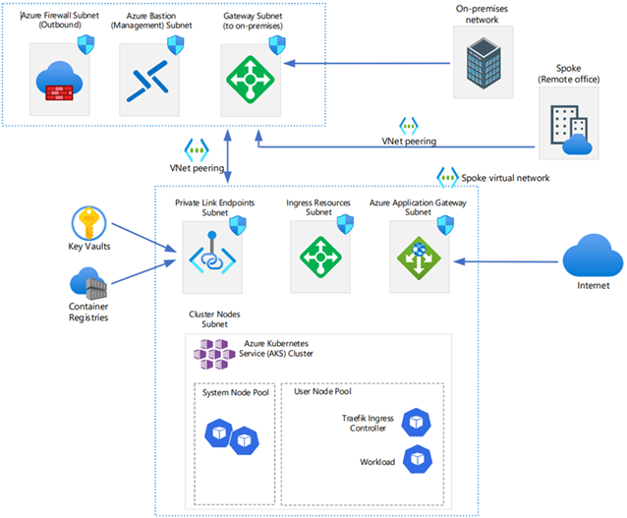

Figure : Azure Kubernetes Services Diagram

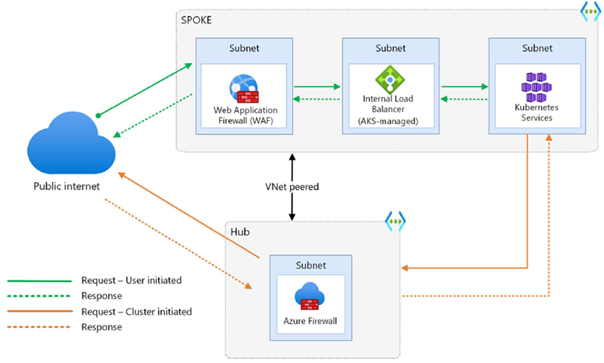

Figure : Kubernetes Orchestration Diagram

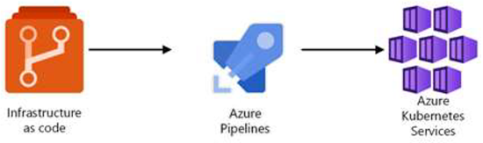

Figure : Cluster Continuous Integration / Continuous Delivery Diagram

### Environment Architecture

The project platform is based on the Microsoft product stack. Applications are developed, tested, and deployed in an Azure cloud environment maintained by DBDriven. DBDriven provides a Development, Test and Production environment capable of supporting the system development lifecycle for all products included in the project contract.

Figure : CNMI Production Environment

Figure : CNMI Development/Test Environment

### Cloud Infrastructure Overview

The SLDS Solution will be solely hosted within the commercial Azure environment and adhere to all contract terms pertaining to security, backups, recovery and performance. Microsoft notifies well in advance of all changes to its cloud environment, and we will provide advanced notice for any discontinuance or change in the SaaS.

The SLDS Solution will leverage the Microsoft Azure Kubernetes Service (AKS) Orchestration, which guarantees uptime of 99.95% for the Kubernetes API Server for AKS Clusters that use Azure Availability Zones and 99.9% for AKS Clusters that do not use Azure Availability Zones. Service Level Agreement (SLA) for Azure Container Apps guarantee applications running in a customer’s subscription will be available 99.95% of the time. Service credits are applied should outages occur and meet the requirements of the specified SLA. Notification of any planned outages are provided before the scheduled event and upon completion.

DBDriven will configure metrics to notify and message any status issues that may cause an outage. The Standard Metrics response can be configured for updates from one min to one hour or higher. Response times are within one hour from reported outage, and resolution time will vary depending on the event. Typically, the following schedule is used for response times based on Eastern Standard Time:

|  |  |
| --- | --- |
| Tier Level (issue) | Response Time (hours) |
| 1 | 4 |
| 2 | 8 |
| 3 | 24 |

Table : Typical Response Time Table

Microsoft does not inspect, approve, or monitor applications that customers deploy to Azure. Moreover, Microsoft does not know what kind of data customers choose to store in Azure. Microsoft does not claim data ownership over the customer information entered in Azure. The SLDS Solution does not claim data ownership in anyway and guarantees CNMI PSS ownership of their data throughout the entirety of the contract.

When the solution deletes data or leaves Azure, Microsoft follows strict standards for deleting data, as well as the physical destruction of decommissioned hardware. Microsoft executes a complete deletion of data on customer request and on contract termination.

### Description of Cloud Architecture

1. **Cloud Service Provider:** Microsoft Azure will host the cloud architecture.
2. **FTP Service:** SFTP service to receive staging files from external data sources. This can be accomplished using an SFTP server deployed on virtual machines or container instances within the cloud environment.
3. **Key Vault:** Utilize a Key Vault service provided by the cloud service provider, Microsoft Azure, to securely store and manage encryption keys, secrets, and certificates required for various components in your architecture.
4. **APIs:** Install and configure the necessary APIs, such as the Trigger API and Imprint API, developed by the technical providers. These APIs will serve specific functions related to data processing, integration, or security within your cloud architecture.
5. **Database:** Azure SQL Database to store and manage structured data.
6. **Data Factory ETL:** Utilize Azure Data Factory or a similar ETL (Extract, Transform, Load) service to orchestrate data movement and transformations between various data sources, including the source database and the reporting database for Power BI.
7. **Power BI Datasets:** Create datasets and reports using the data from the reporting database. Power BI connects to the database and structures the data for reporting purposes.
8. **Application Registration:** Applications created and registered at the enterprise level to secure them and prevent unauthorized access. Involves configuring authentication, authorization, and access control mechanisms. Clients and Secrets need to be updated every two years.

## SLDS Data Warehouse and Reporting Technical Overview

This section documents and diagrams the dataflow processes from the external data sources. External data sources are defined as the CNMI PSS source systems, which currently store the student, staff, finance, and assessment data needed to populate the public school system reports.

The primary data provider for the reports is the K12 SLDS. Student, staff, finance, and assessment data updates are provided per the data refresh Table 2 from the SLDS. All report components, to include the stored data transferred from the external data sources, are retained within Azure.

The CEDS aligned SLDS data warehouse supports the generation of the federally required EDFacts reports by moving data from source systems to the Generate staging tables for processing by the Generate Application. DBDriven built translations between the data model descriptors and the corresponding Generate codes. Further, DBDriven modified out of the box descriptors to better align with CEDS, giving these descriptors back to the community to promote CEDS alignment and compatibility.

### Data Flows

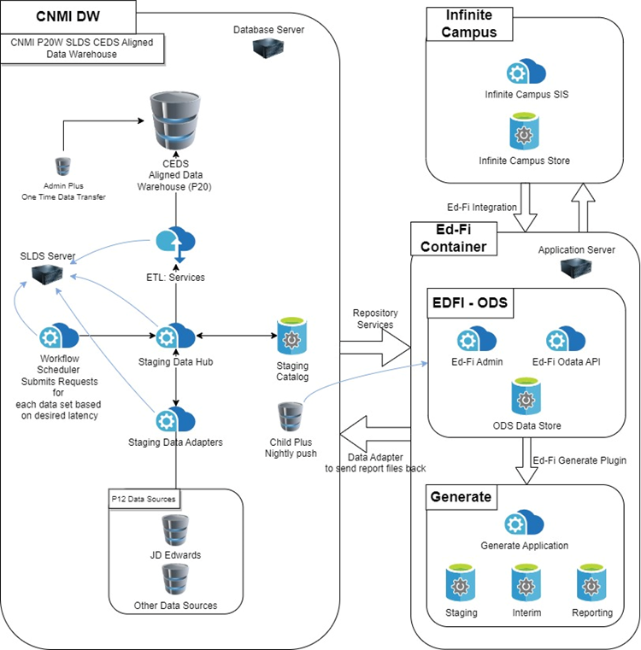

Figure : PK-12 SLDS Solution

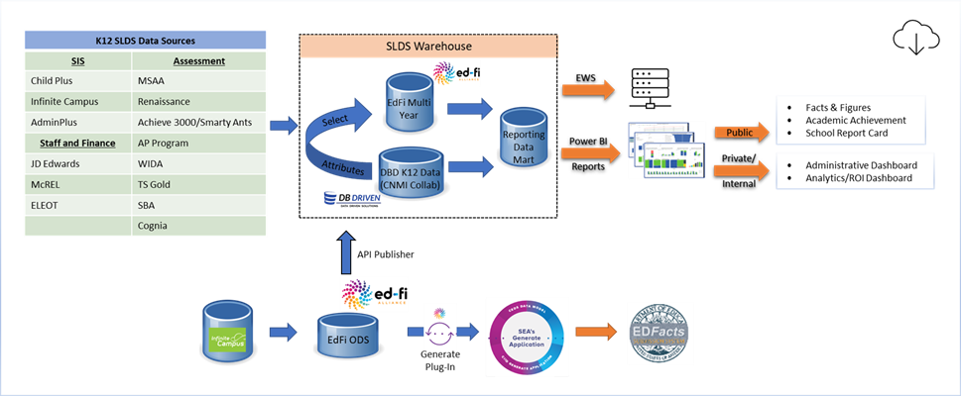

Figure : PK-12 SLDS Data Warehouse and Reporting Data Flow Diagram

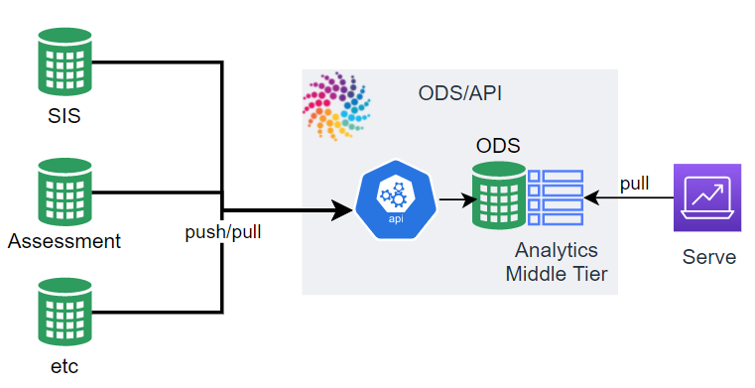

Figure : Power BI Reporting Data Flow Diagram

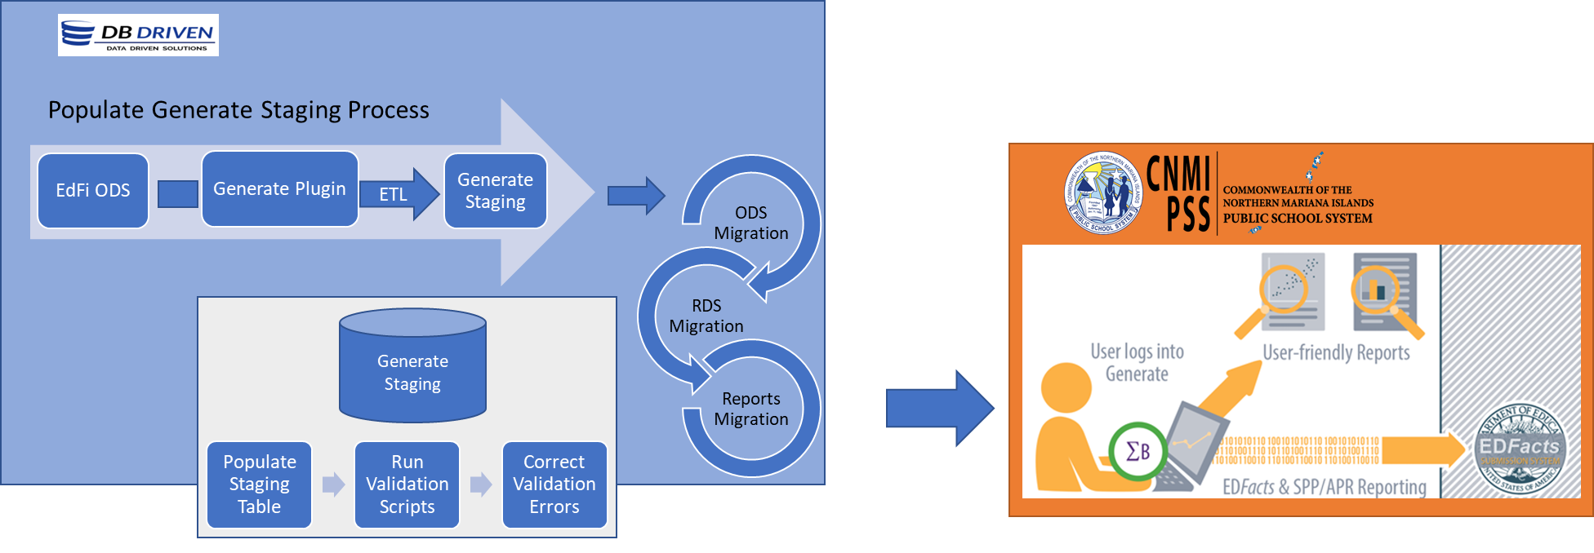

Figure : Generate EDFacts Reporting Data Flow Diagram

### Data Transfer and Refresh

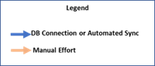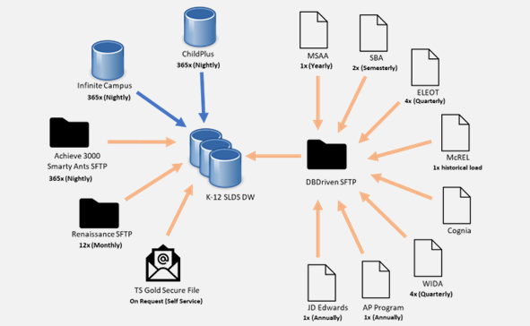

Figure : SLDS Data Warehouse and Reporting Data Transfer and Refresh Diagram

|  |  |  |  |
| --- | --- | --- | --- |
| **ID** | **External Data Source** | **Dataflow Description** | **Refresh Rate** |
| DF1 | CNMI Data Pipeline | Generate Plug-in | 365x Nightly |
| DF2 | Infinite Campus | SIS Database🡪EdFi Sync🡪SLDS (K12DW)  K-12 Data | 365x Nightly |
| DF2 | Child Plus | SIS Database🡪EdFi Sync🡪SLDS (K12DW)  Pre-K Data  100+ tables, 4000+ attributes | 365x Nightly |
| DF3 | MSAA | SFTP (DBD)🡪SLDS (K12DW)  Assessments  2 tables, 101 attributes, 115 records | 1x Annually |
| DF4 | SBA | SFTP (DBD)🡪SLDS (K12DW)  Assessment Data  2 tables, 46 attributes, 1670 records | 2x per year, Semesterly |
| DF5 | WIDA | SFTP (DBD)🡪SLDS (K12DW)  EL Assessment Data  4 tables | 4x Quarterly |
| DF6 | AP Program | SFTP (DBD)🡪SLDS (K12DW)  Assessment Data  30 tables, 262 attributes, 3877 records | 1x Annually |
| DF7 | Achieve 3000, Smarty Ants | SFTP (Vendor)🡪SLDS (K12DW)  Early Start / Assessment Literacy  1 table, 58 attributes, 9322 records | 365x Nightly |
| DF8 | Renaissance | SFTP (Vendor)🡪SLDS (K12DW)  Assessment Data  11 tables, 126 attributes, 856,723 records | 12x Monthly |
| DF9 | TS Gold | Vendor download/SFTP (Vendor)🡪SLDS (K12DW)  Assessment Data  1 table, 140 attributes, 4423 records | 5x per year |
| DF10 | JD Edwards | SFTP (DBD)🡪SLDS (K12DW)  Staff and Financial Data | Monthly (phase out July 2023) |
| DF11 | AdminPlus | K-12  516 attributes | One Historical Load, Years 2018-2020 |
| DF12 | ELEOT | SFTP (DBD)🡪SLDS (K12DW)  Survey | 4x Quarterly |
| DF13 | McREL | SFTP (DBD)🡪SLDS (K12DW)  Survey | 1x historical file  12x Monthly (once new system in place) |
| DF14 | COGNIA | SFTP (DBD)🡪SLDS (K12DW)  Survey | HOLD(?) |

Table : SLDS Data Warehouse and Reporting Data Transfer and Refresh Table

## EWS Technical Overview

The primary data provider for the EWS solution is the K12 SLDS. Student and assessment information updates are provided nightly to the EWS from the SLDS.

The EWS generates and stores data necessary for operation of the solution, such as intervention data and risk indicator data in the EWS Operational Database. All EWS components, to include data, will be retained within Azure.

### Data Transfer and Refresh

This section identifies all requirements surrounding the refreshing of data. Data refresh requirements include descriptions of data to be refreshed and the frequency of data refresh.

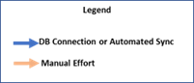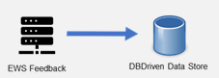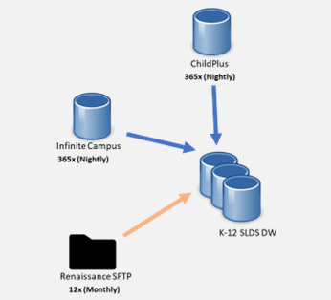

Figure : EWS Data Transfer and Refresh Diagram

| **ID** | **Agent** | **Data Coming From Data Source** |
| --- | --- | --- |
| DF1 | ChildPlus | Preschool Experiences |
| DF2 | Infinite Campus | Name Grade Level Discipline ELA Grade  Attendance SpEd Mobility ELL Retention |
| DF3 | Renaissance | STAR Early Literacy STAR Reading |
| DF4 | EWS | Feedback entered by CNMI PSS staff on student intervention actions |

Table : EWS Data Transfer Table

| **ID** | **Dataflow Name** | **Dataflow Description** | **Refresh Rate** |
| --- | --- | --- | --- |
| DD1 | ChildPlus | Refresh of pre-school/kindergarten data | Nightly |
| DD2 | Infinite Campus | Refresh of K-12 data | Nightly |
| DD3 | Renaissance | Refresh of STAR Assessment data | Monthly |

Table : EWS Data Refresh Table

### Data Ingestion

The required data sources for EWS will populate in the EWS Staging. This section diagrams and explains how data flows from the staging environment.

The data is stored in the EWS Staging Environment to transform the data and create datasets where applicable for an efficient EWS reporting. A web app allows users to interact with the dashboards and submit information for feedback (intervention, actions taken, indicator effectiveness, scoring administration, etc.).

Data events trigger the EWS ETL to process or refresh the data (total or selective processing) for an updated view of the EWS in near real-time in conjunction of the Ed-Fi refresh schedule. When data events are detected, data services initiate a series of processes to update the datasets, which in turn refresh the EWS front-end. The data events are determined by the CNMI stakeholders. Figure 8 shows the process for when the data events are fired.

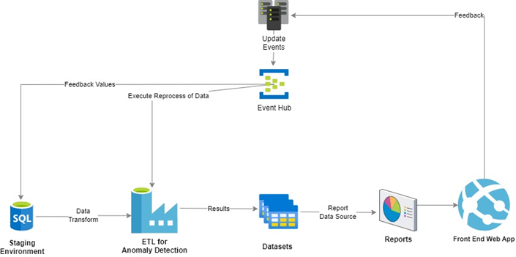

Figure : EWS Data Ingestion Diagram

### Data Factory Data Flow

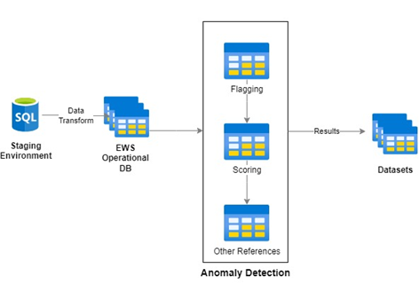

Figure : EWS Data Factory Data Flow Diagram

## P-20W Technical Overview

This section documents and diagrams the high-level components and dataflow processes of the P-20W. The P-20W components include:

* Agency Governance Portal
* Researcher Portal
* Workflow
* Data Manager
* Data Hub / Adapters
* Data Dictionary and Selection Tool
* Data Request Tool

The data from the PK-12 SLDS data warehouse feeds the P-20W system for research and reporting efforts.

The **Workflow** component serves as the central nervous system for the proposed solution. It manages the full spectrum of account, data, document and user management. It includes automated workflows and auditability. Workflow monitors and triggers actions such as query submission and maintains status of requests. Moreover, Workflow is the source of information about roles and permissions for authorized users. All business administration and governance of the system is executed through the CRM application. The system tracks all communication and activity within the system including all emails, approvals, data access and use policies, request for data and results downloads.

The workflow component provides automation and monitoring of user actions, including creation, submission transport, notification, approval or rejection of account and data requests. The workflow component provides email notifications for new, pending and completed requests.

The **Data Manager** is an inventory of every available data field in every available data source, the structure of their storage, the possible values and meanings of the information stored. The Data manager provides a friendly web interface for adding/deleting/modifying agencies, tables, columns and valid values.

The **Data Hub** is responsible for querying the agency data sources, matching the records in a de-identified manner, creating final de-identified data sets, and communication with the Workflow solution. To execute these tasks successfully, the Data Hub understands the structure of the data sources and the relationships between them.

The Data Hub uses the Data Manager to obtain the structure and relationship information. In querying the agency data sources, the Data Hub has responsibility for dividing the submitted query into smaller queries (sub-queries) and devising an optimized plan of execution that can be executed against each target data source.

The **Data Request Tool** (DRT) is an ad hoc query capability, which allows users to design, develop and save data requests. The DRT is accessible to named users from within the Researcher portal. At the fundamental level, the DRT allows researchers to define the columns of the data they are requesting, the filters that apply to their requests, and whether the result(s) should or should not include matched or unmatched data.

The **Data Dictionary and Selection Tool** is available to named users in the Researcher Portal. The Data Dictionary provides a complete inventory of available data, data source(s), the structure of available data, and the possible values and meanings of the information stored. The Selection Tool allows researchers to select the tables and columns of data they want access to as part of their research.

Figure : P-20W Solution

Figure : High Level Governance Process

Figure : P-20W Use Case Diagram

Figure : Data Manager Use Case Diagram

Figure : MS Dynamics Technology Stack

Figure : Research Portal Technology Stack

Figure : Data Adapter Technology Stack

Figure : Data Hub Technology Stack

# Implementation Plan

Artifacts for the Project reside within two environments:

* Microsoft Azure DevOps (ADO)
* Microsoft SharePoint (i.e. Project Repository)

ADO is designed to allow project teams to work in a collaborative and efficient manner and link related items. DBDriven uses ADO throughout the lifecycle of the project so that items may be linked together, and a history may be built of the project process.

The reporting features in ADO allow DBDriven to generate detailed information as requested by project members or as needed for Project Management and/or Stakeholder meetings. Access to ADO is limited to the direct DBDriven Team and the Project Management Team to ensure strict adherence to the processes.

ADO is the primary source code and document repository. It has features to associate source code changes with development, bugs, and change request tasking. DBDriven leverages this capability to provide traceability of source modifications to development and design tasking through to requirements and, ultimately, to the original capability statement.

Items maintained in ADO include:

* Work items
* Source code, Database scripts and Reference data scripts
* Testing items

The Project Repository, SharePoint, is accessed through a website for the key elements that are visible to the Project Management Team and others upon request. The Project Repository website is available to all who request access which is controlled through groups and permissions. The Project Repository is set up to maintain two main types of data:

* Lists
* Documents

## System Development Lifecycle

DBDriven employs an adapted agile methodology as the System Development Lifecycle and Change Management processes.

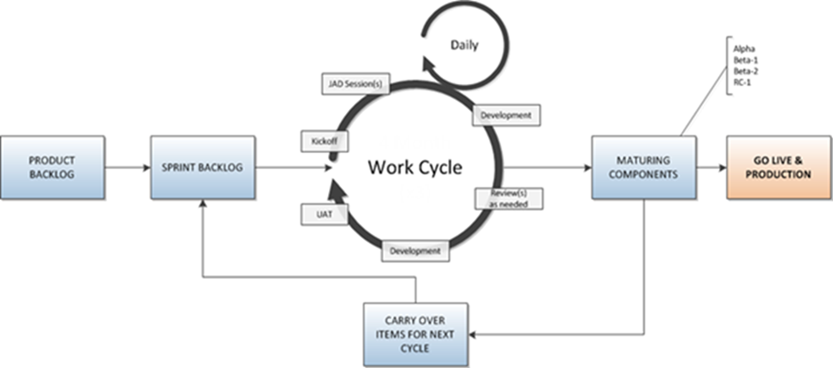

Figure : Adapted Agile Methodology

Business (functional and non-functional) and technical requirements in scope to the project are documented in a Requirements Traceability Matrix. The Requirements Traceability Matrix feeds technical and use case specifications, user stories, and technical design to create the initial requirements documentation. The initial documentation supports the baseline of requirements established and entered in an agile software tool for configuration management. We leverage Microsoft Azure DevOps (ADO), an industry standard tool that serves as the code repository which provides for:

* Configuration management
* Build management and automated builds
* Release management and automated releases/deployment
* Version control
* Requirement management and development traceability
* Test management
* Artifact management
* Change management
* Ticket and Issue management

ADO documents and controls all changes to requirements, design, and code through a series of features and organization. DBDriven conducts agile sprints to manage product work, versions, and builds. The output of work product developed during the agile sprints is combined with a release. A release is composed of one or more user stories which are logically organized to undergo Unit and Integration Testing completed by the Testing Team, Business System Analysts and the Project Manager.

Requirements documented in ADO are organized in a hierarchy:

1. **Epic**: A collection of related features
2. **Feature**: A software component to deliver
3. **User Stories**, **Bugs** and **Tasks**: Granular work items to track work and changes

ADO supports the change request process by tracking work with development features:

1. **Create Branches**: Work items are directly linked to a branch of work by a developer
2. **Pull Requests**: Initiates code review by a senior developer once work is checked-in
3. **Work Status**: Notifies when work is ready to test and resolved/closed

ADO supports regular testing with test features:

1. **Test Cases**: Steps to execute exhaustive testing of the user stories
2. **Testing Execution Tool:** Documents the results of each step of the test cases

### Source Code

* Application code
* Conversion/Migration code
* Database scripts
* Reference/Configuration Data scripts

### Testing Items

* Test Cases
* Test Steps
* Test Results
* Defects/Bugs
* Test Data

## High-Level Schedule

Figure : High Level SLDS Solution Schedule

# Tests

DBDriven provides user manuals and training as a guide to the web-applications. The public facing reports are designed to drive intuitive interactions without the need for a user manual. However, tooltips and footnotes are included in the public reports where additional information is essential.

Each project development release is thoroughly tested to ensure the highest level of quality. CNMI PSS has the opportunity to perform testing of new versions and releases of the solution in the User Acceptance Test (UAT) environment to ensure existing functionality is not compromised. All new releases are regression tested via automated scripts, both APIs and UI, when going through the automation pipeline as well. Other regression and smoke testing is performed by DBDriven's testing team for another level of quality assurance.

UAT demonstrations are conducted by DBDriven prior to the start of UAT by the end users. Users receive a UAT Test Plan and Test Cases to execute. DBDriven ensures Test Cases meet the requirements and the screens, forms, workflows, reports and other end-user items are tested thoroughly. We provide the Test Plan, Test Cases, a document with the list of key items to be noted for UAT along with a spreadsheet to track/capture questions and issues.

## Peer Review Management

DBDriven software testing practices include unit testing by the developer with a unit test check by a senior developer as well as system testing by the system analysts and project manager prior to acceptance testing.

Our Peer Review Management process includes:

1. Planning & Design: Conducted by the Lead Engineer and informs the development team of the required guidelines, design, constraints, and objectives.
2. Code Review & Feedback: Entire development team conducts code review together. Code is reviewed for correctness, completeness and adherence to requirements.
3. Re-review (as required): Entire development team conducts code review together. Code is reviewed for correctness, completeness and adherence to requirements.
4. Documentation: ADO serves as the source repository for all code and associated documentation from peer reviews.

# Runbook

The SLDS solution for public, private, and EDFacts reporting, the EWS, and the P-20W are all web-based and launched by accessing the reports or web applications at the designated website URL in a web browser. The EWS and P-20W require user authentication and authorization to access the web applications.

DBDriven provides an Operations and Maintenance team to adequately respond to system level support requirements. The O&M team conducts routine infrastructure maintenance, health checks, review of security measures and schedule of releases to deploy optimal solutions to guard against incidents. Incident management is thoroughly conducted by analyzing the root cause and recommending a solution to implement. System and database level performance monitoring, updates, and patches are carefully evaluated and applied.

DBDriven provides enhanced external monitoring and outage alerts for critical application events to initiate prompt service failure resolution. Software used for system monitoring include:

* Prometheus
* Azure Metrics
* Azure Log Analytics